Canva for beginners

Canva is an app/website which you can use to edit/create content as a business. It is perfect for creating logos, adding watermarks to pictures & creating social media content such as price lists, educational posts, highlights.
As beauty professionals it is a perfect tool to use to up your social media game.

You can find the app by searching ‘Canva’ on the app store or google play store. Alternatively, you can search www.canva.com on a web browser.

The free version of Canva can be used, but to take advantage of all the tools available, we recommend purchasing the ‘pro’ version of the app. There is usually an option for a free trial, then it is £12.99 a month.

Navigating Canva

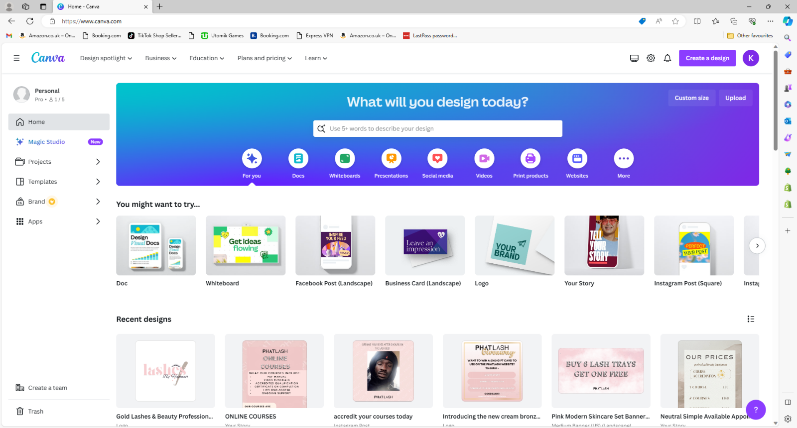
The first thing you will see on the app is this page.

Here is what each button will do.
The search bar will allow you to search for templates. Such as ‘beauty price list’ ‘giveaway Instagram post’ etc.

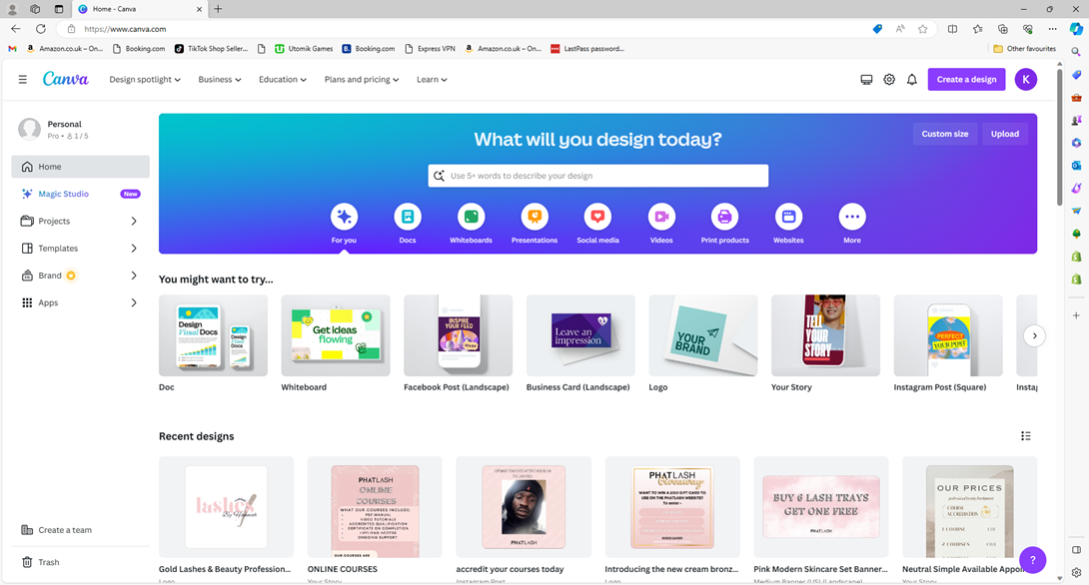
This slider gives you more template options. You can select the type of media you need and narrow it down. As do the buttons below the search bar.

Creating a logo
In order to showcase the tools you can use in Canva, I am going to create “social media” bundle for a lash artist. As I go through, I will demonstrate and give instruction on how to do each edit/use each tool.
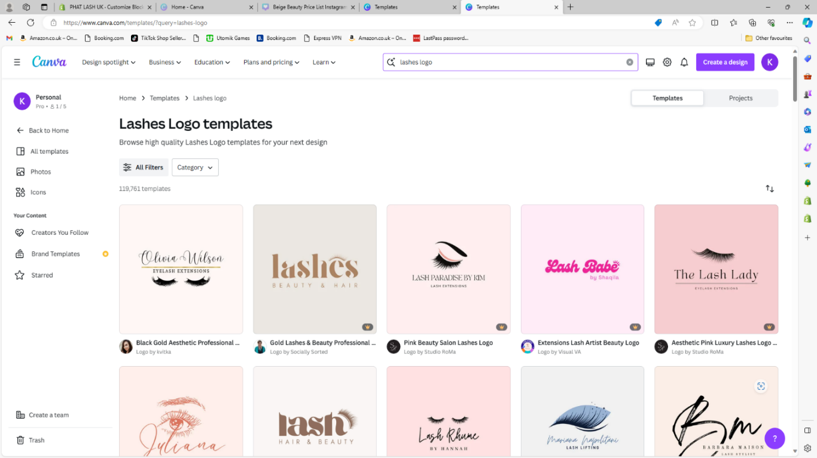
So, the first thing we’re going to do is search for a logo template. I have used the search ‘lashes logo’.
Once you find one you like, you can either change the text to say your own business name, or do extra edits to make it more unique and suited to yourself.
I have entered ‘lashes logo’ into the search bar.

I have chosen this one here.
The first thing I’m going to do is change the text to say ‘Lashes by Hannah’ which is the name of the business I chosen. To do this will leave the word ‘lashes’ as is & select the ‘beauty & hair’ text to change this.
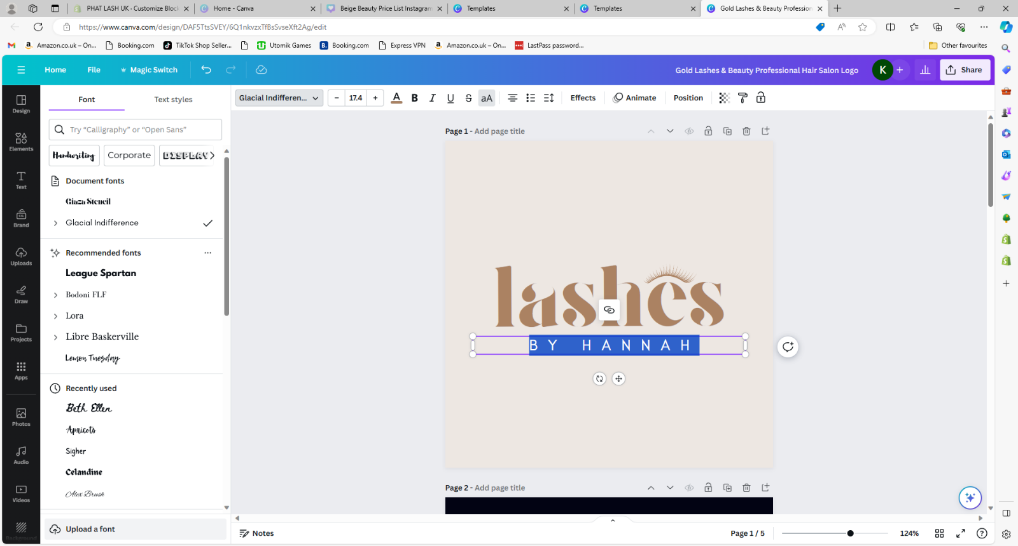
I am now going to change the font of the text by highlighting it, and selecting the font drop down.

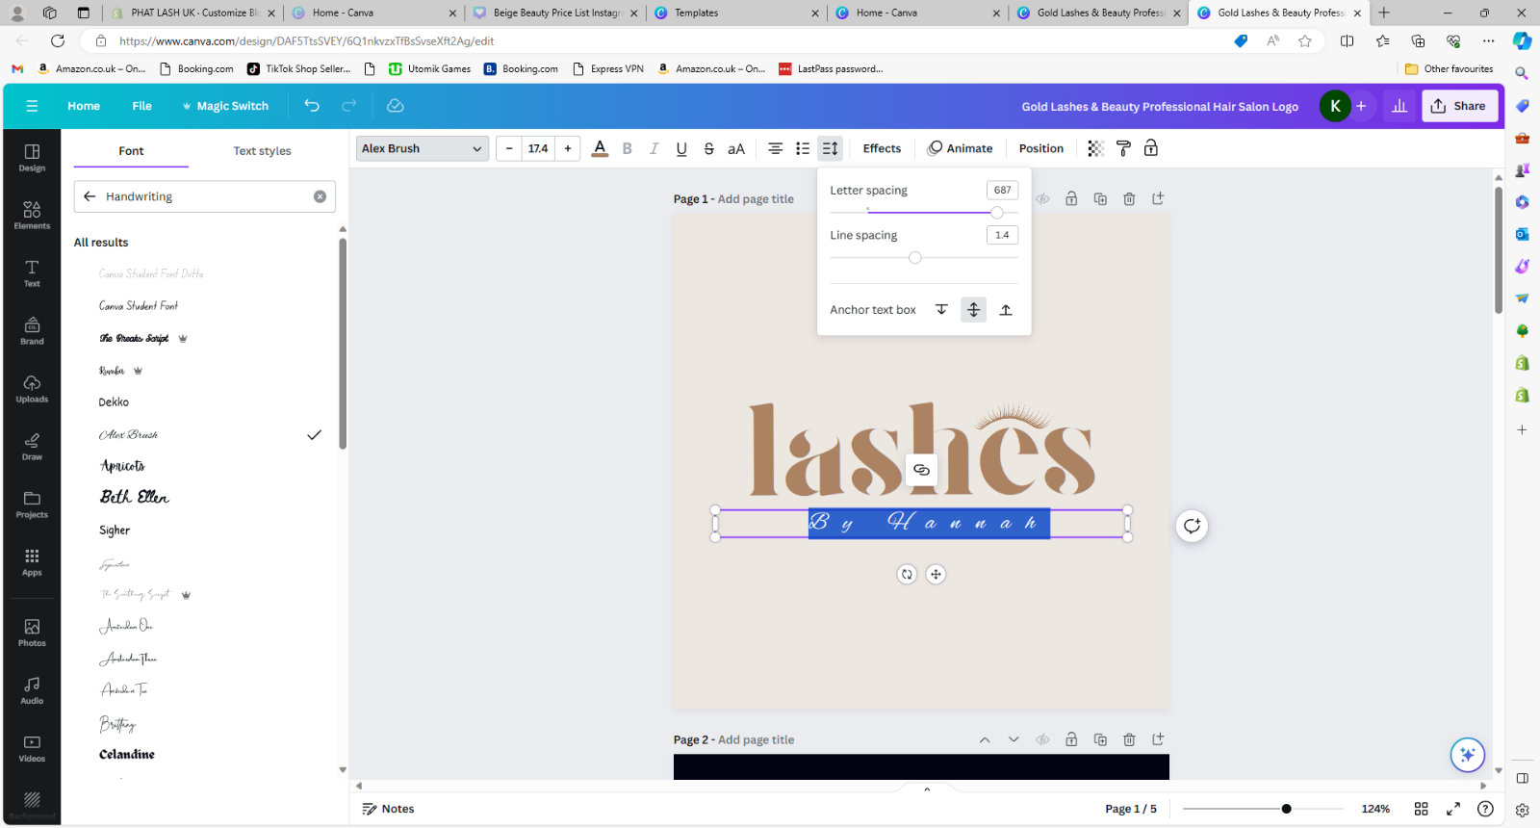
I am then going to select the handwriting section show me a selection of font that will give me the cursive vibe I am going for.
I have selected the font ‘Alex Brush’. As you can see, I am going to need to change the letter spacing to make the text appear ‘joined up’.

I select the ‘spacing button’ and use the slider to bring the letter spacing down, until it is as close together as I desire.
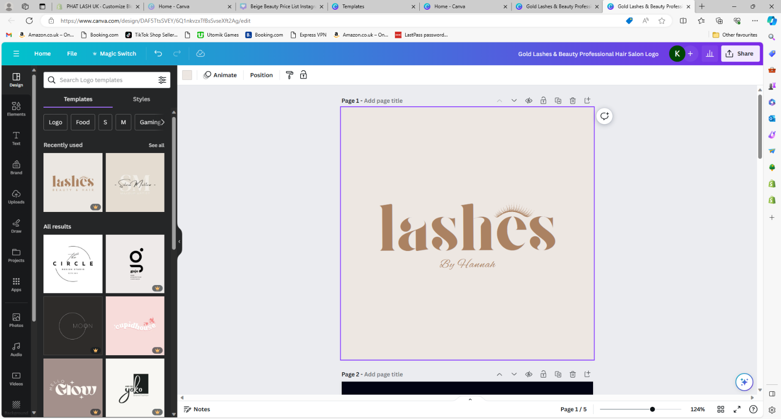
As you can see the text now looks like cursive writing and is exactly the way I want it.

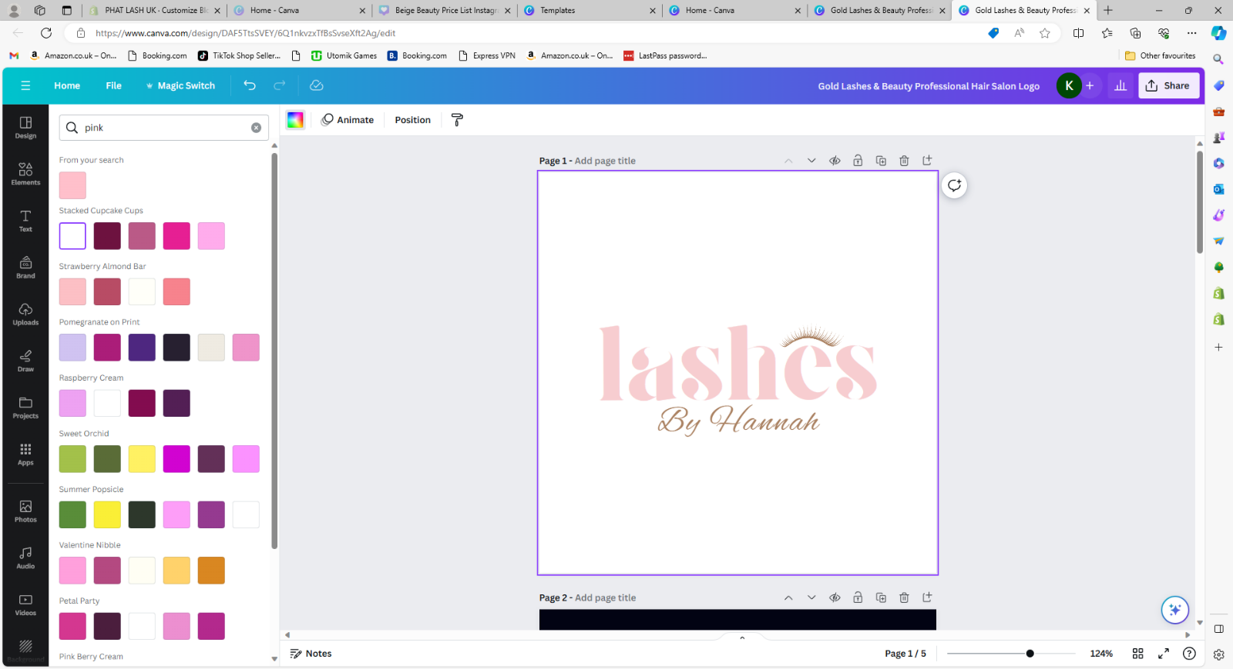
I now want to begin changing the colours of the logo, starting with background. I select the background and then go to the colour changing tool and selecting white.
Then, I move on to changing the colour of the word ‘lashes’. I do this by selecting the word and then opening up the colour changing tool once more and searching for ‘pink’. After trying out a few options, I go with my favourite.

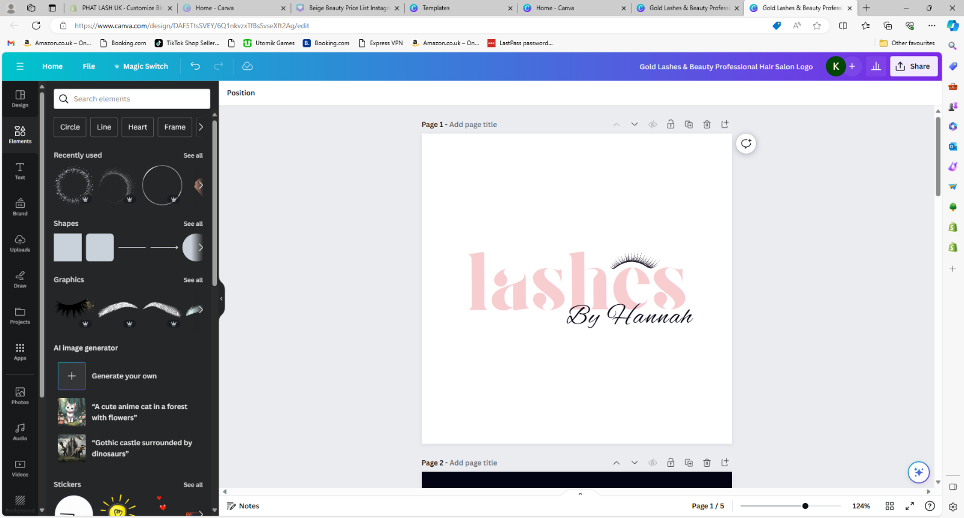
I am now going to follow the steps we have already been through, but to change the lash image & ‘By Hannah’ to black as you can see below.

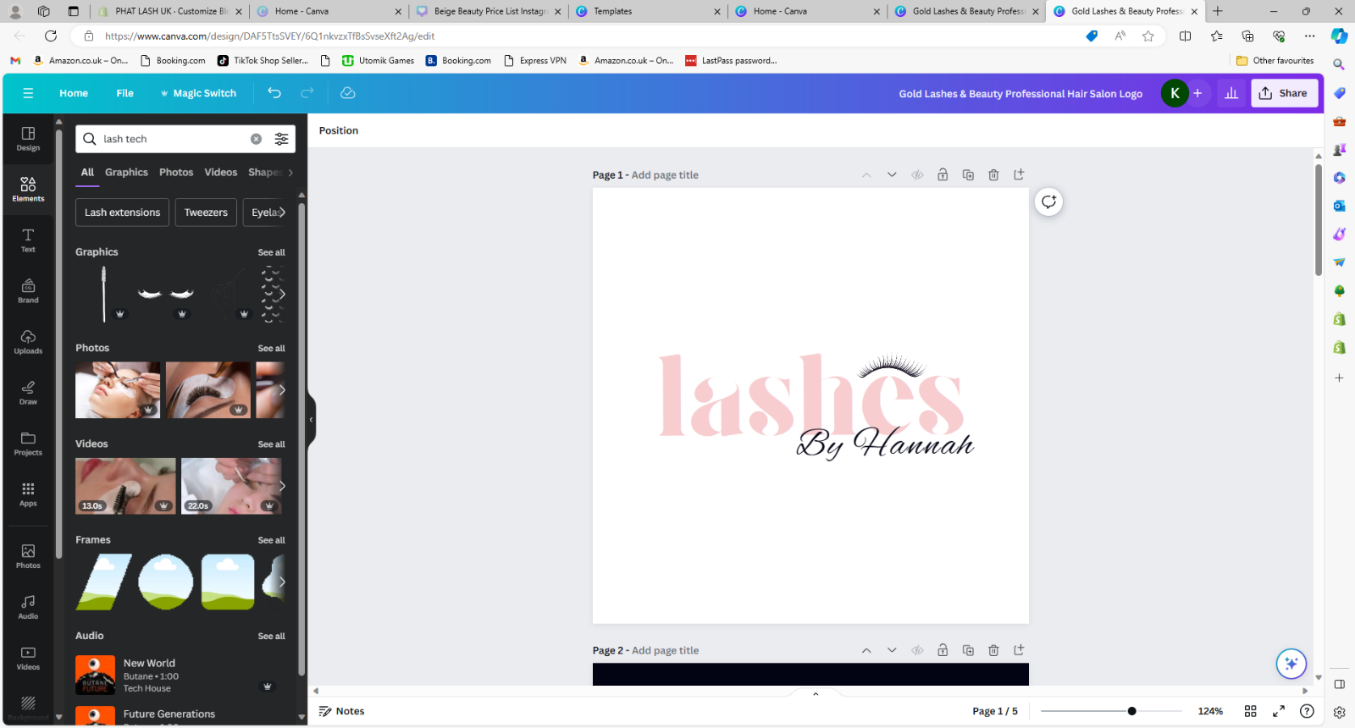
Next, I am going to add a graphic to customise the logo even more. I am going to select ‘elements’ off the side menu.

Into the search bar, I am going to enter ‘lash tech’ then select the ‘see more’ button on the ‘graphics’ section. This will open a section of graphics you can browse and add into your logo.

I select the graphic I want to add, which is some tweezers. I then select and drag this onto my logo.

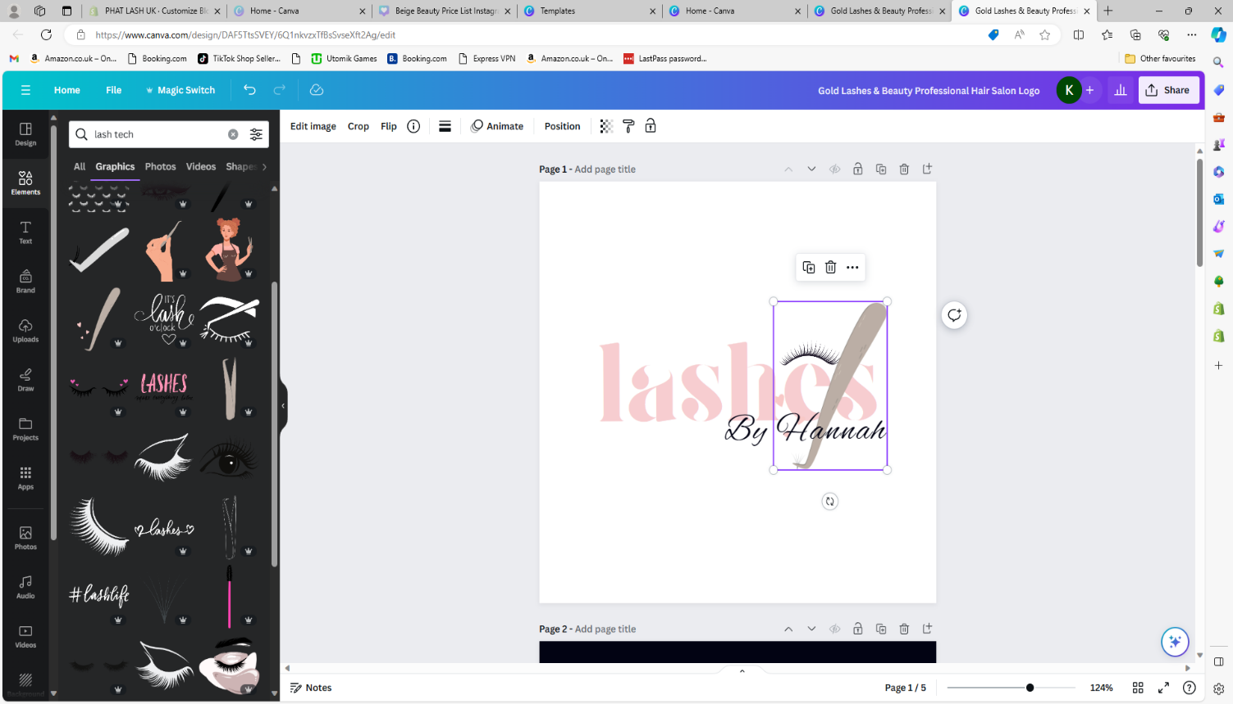
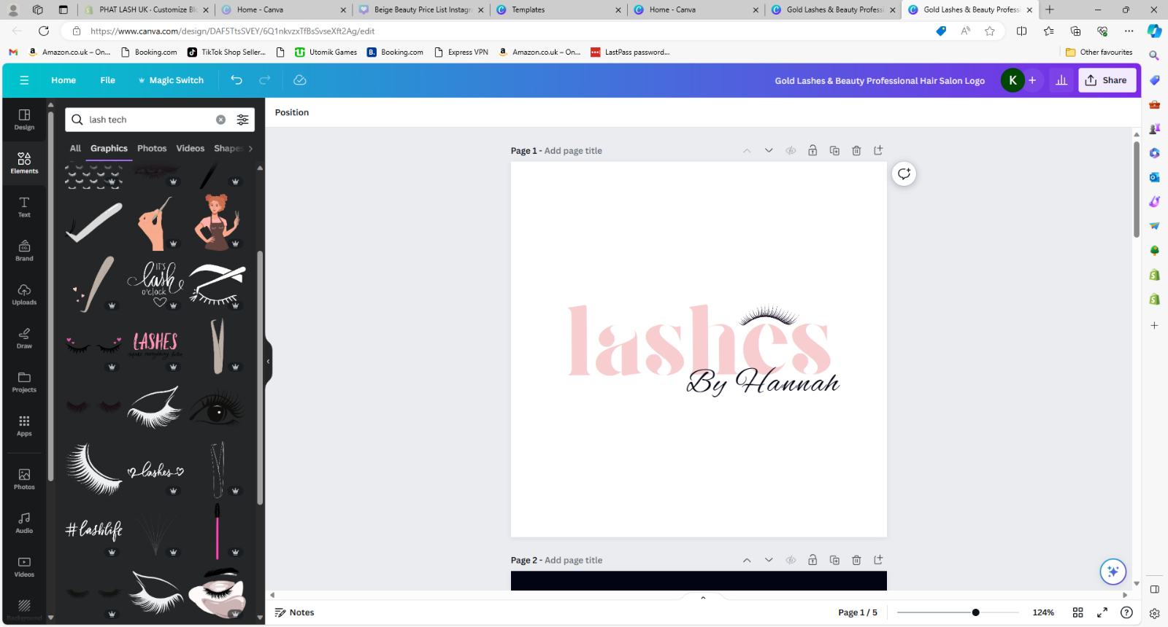

Once I have done this, I want to move the graphic to the background of the logo. To do this I will select the graphic, then click on the ‘position’ button’.
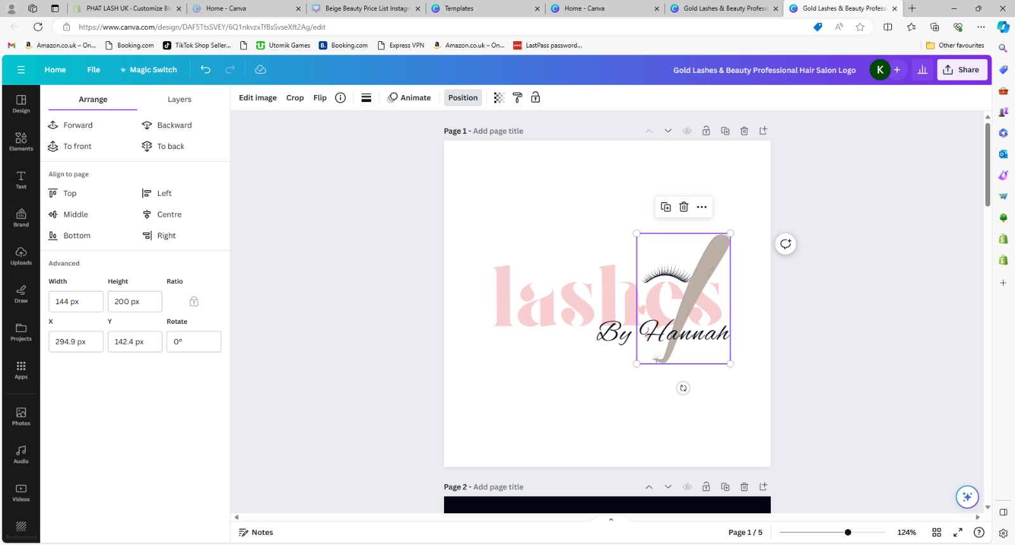
I can then choose the option to send ‘to back’. This will place the graphic behind everything else on the page.
Once you are happy with this version of your logo, you can save this to your computer.

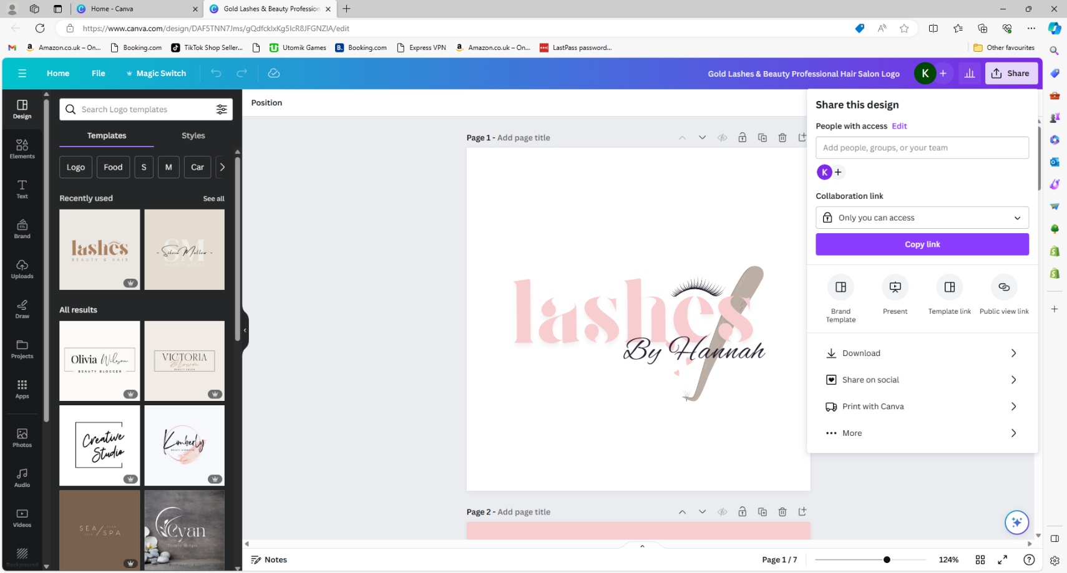
To do this, all you want to do is select the ‘share’ button and select ‘download’.
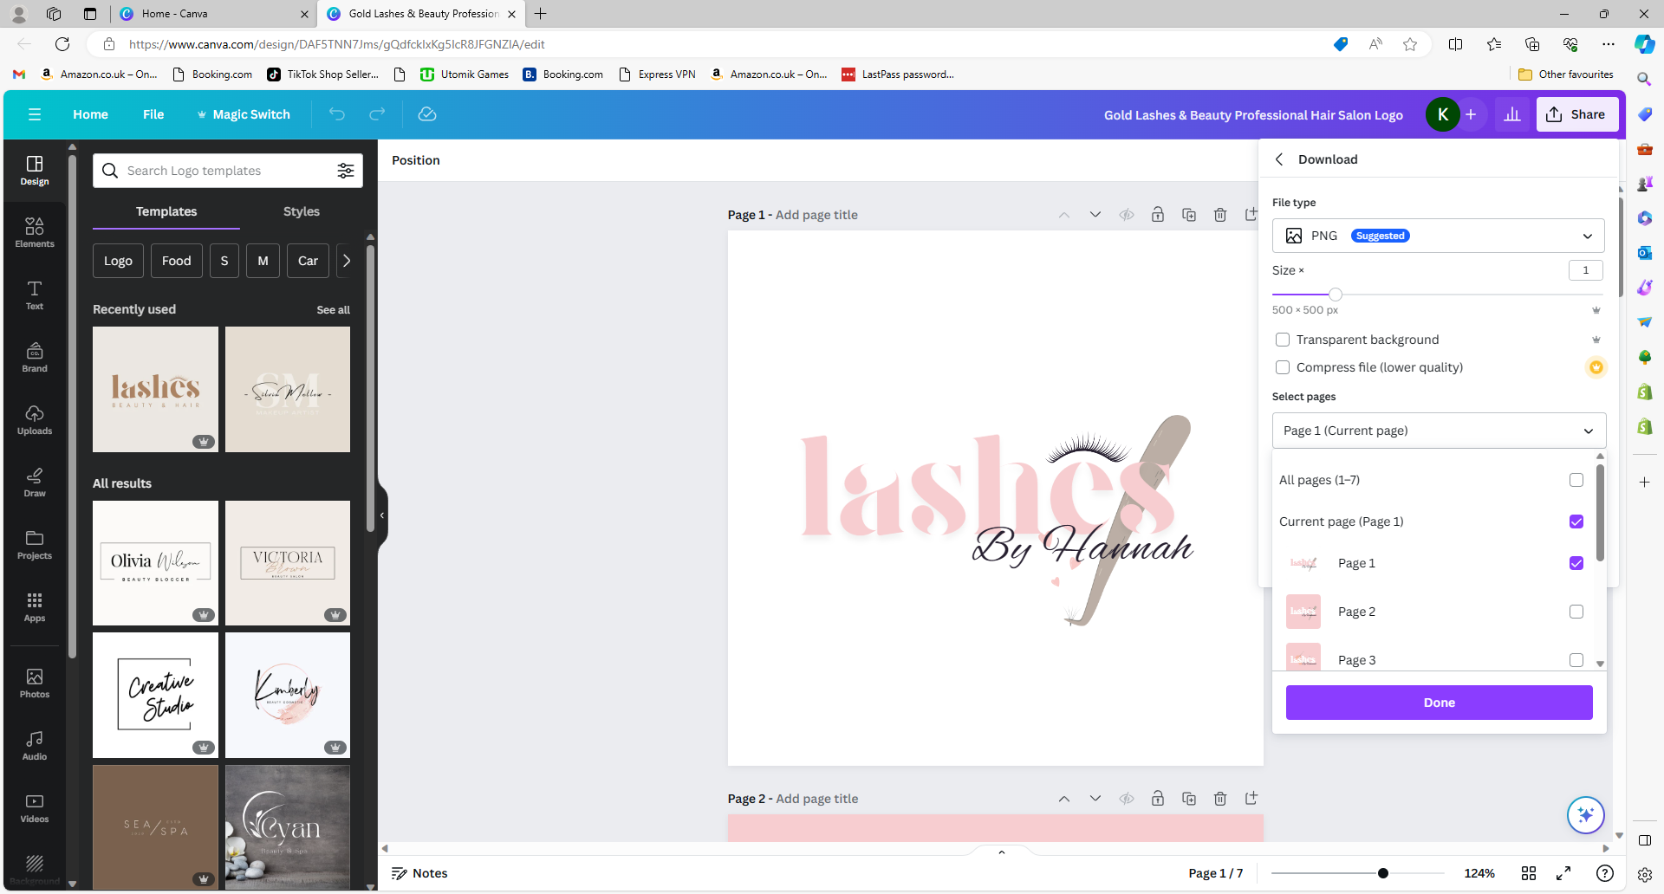
As I have more than one page open, I am going to go to the ‘select pages’ drop down, and select ‘current page’.

I will then select ‘done’ before clicking the ‘download button’.

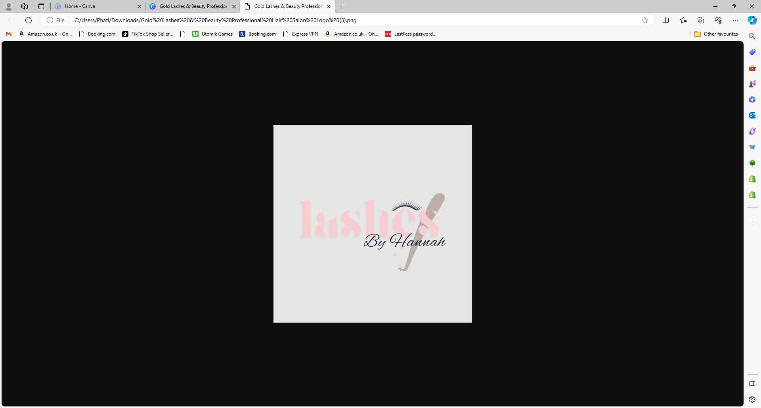
If you want to save your logo as a watermark version, you will select ‘transparent background’ and then download it the same way as previously described.
This is what the download will look like. When you add this logo into images, there will be no white background. Only the text and graphics will show.
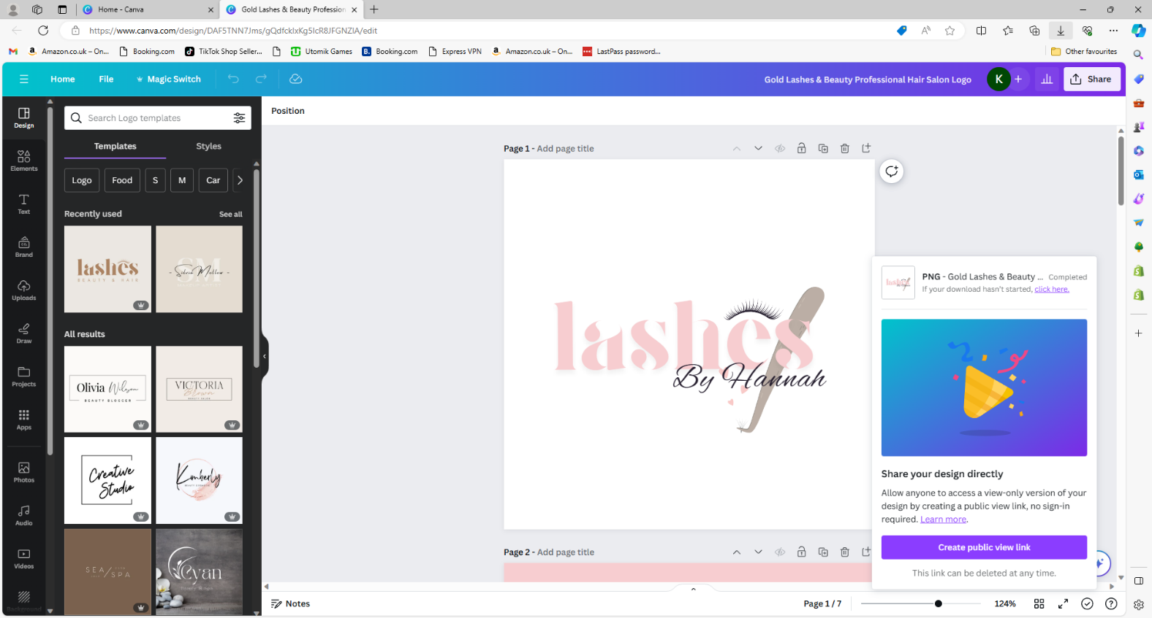
Once your image has downloaded, your screen will look like this...

Uploading your own pictures/images into Canva
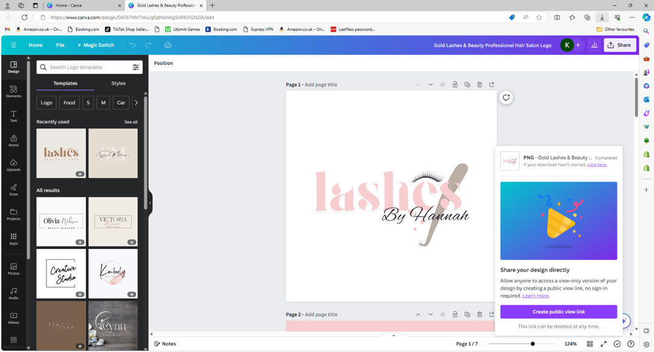
To add your own images into Canva you are going to want to use the uploads section.
.
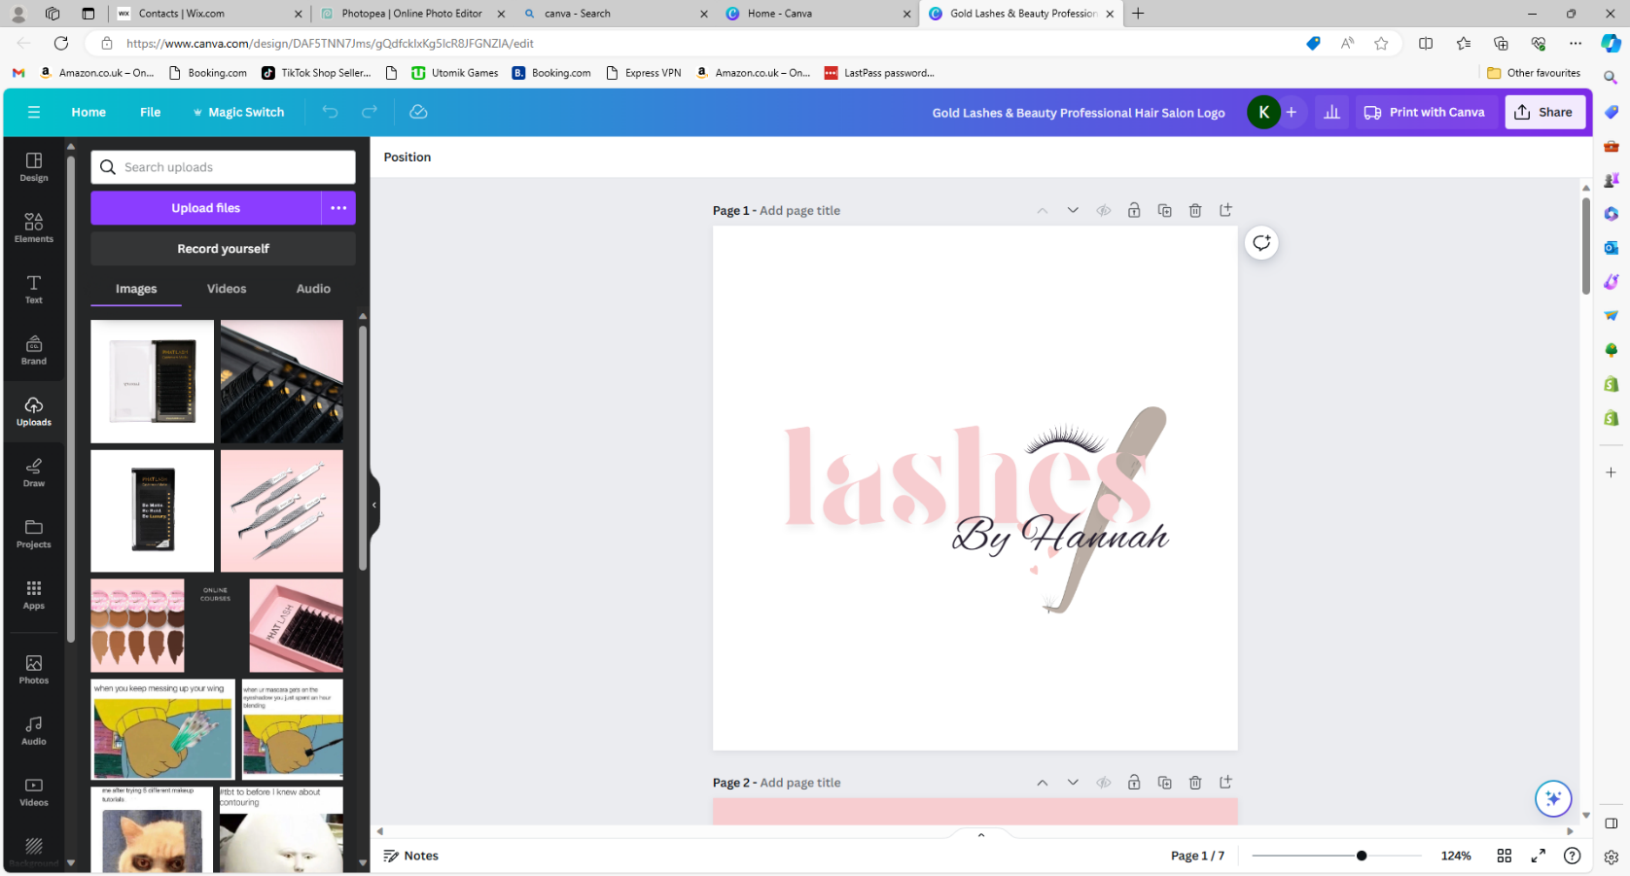

Here you can view all of your previous upladed images & upload any others by selecting the ‘upload files’ button, then selecting files from your computer.

I’m going to upload a picture of some lashes & also my logo.
I will then make the picture of the lashes the full size of the post template.
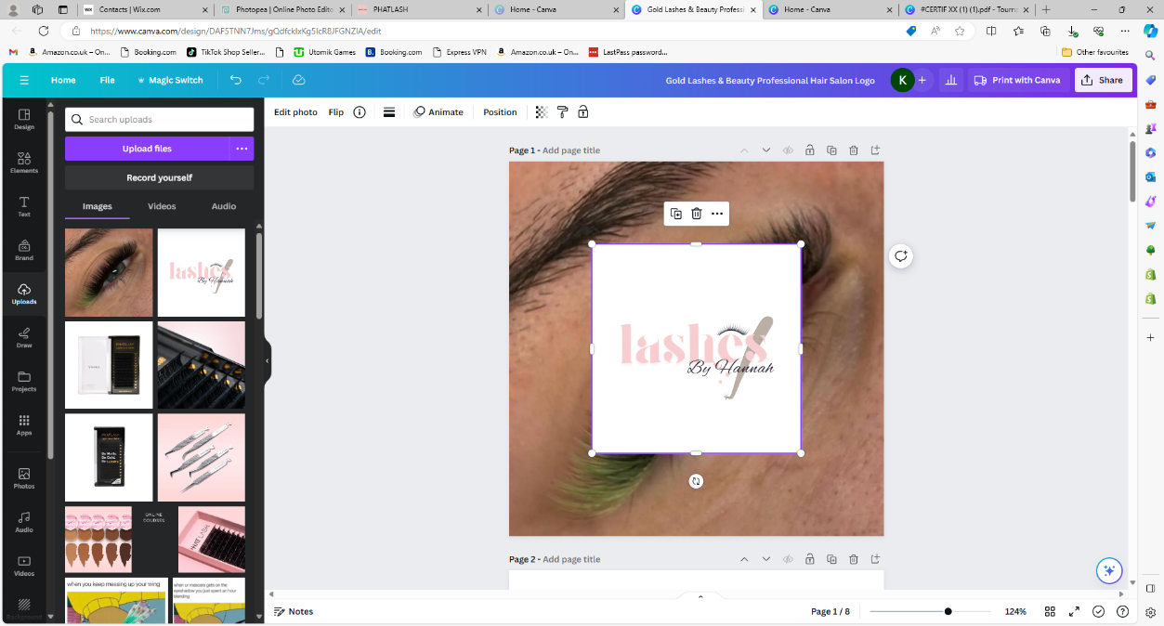
after this, I will remove the background from my logo by selecting it and clicking the ‘edit photo’ button. I can then choose ‘remove backgroud’.
I’m then going to place my logo in the bottom right corner. This is just personal preference. You can place it wherever you desire. I will then download this image in the same way I have previously shown. It’s now ready to be uploaded to my social media.
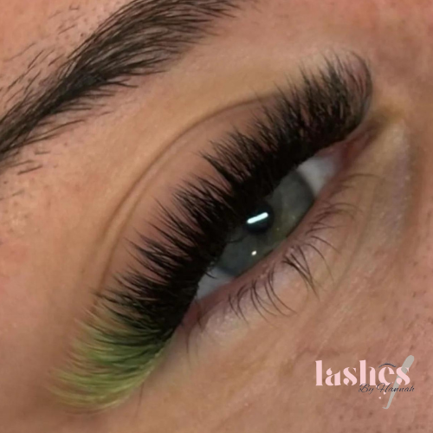

Instagram post
The next thing we are going to be talking about is how to create eye catching Instagram pictures. We will be demonstrating this by creating an Instagram post for sales that we will be putting on.
The first thing to do is go into Canva and click the ‘Instagram post’ template.

the first thing you will need to do is choose a background for the picture we would recommend using a texture background as it is more eye-catching instead of just a plain colour one. This can either be created using a picture of your products or searching a picture and placing that as a background.

For example,
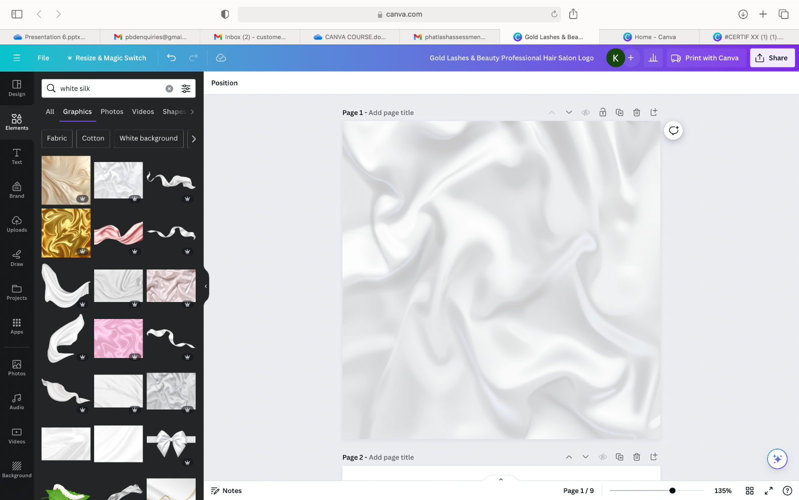
For this we just searched white silk in the ‘elements section’ on the left-hand side of the screen.

You could leave your background as this, however sometimes this can distract from the contents of the Instagram post. We can soften the background by using the transparency tool.
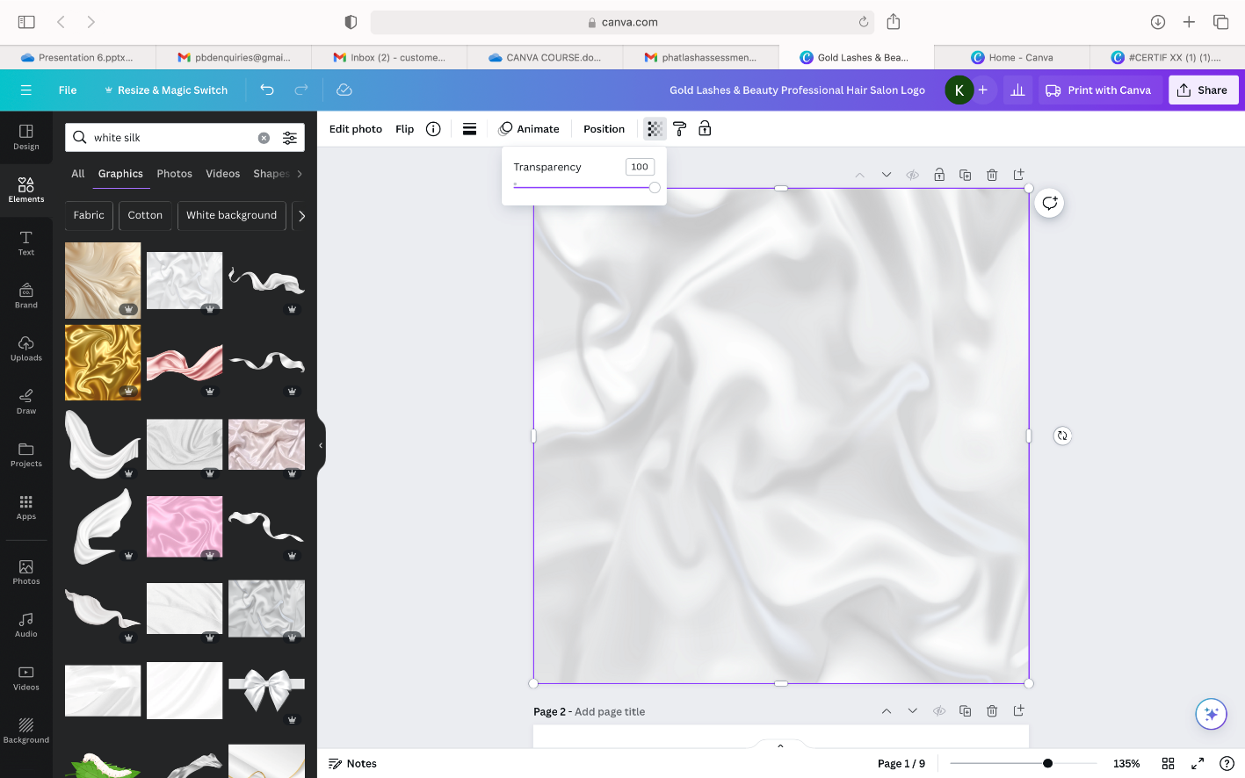
To soften the background image, click on the image and a button will pop-up at the top of the screen with darker to lighter squares. If you click on this, you will be able to change the transparency of the image making it less bold as the background.
This can be adjusted however you see fit by using the scrolling button.
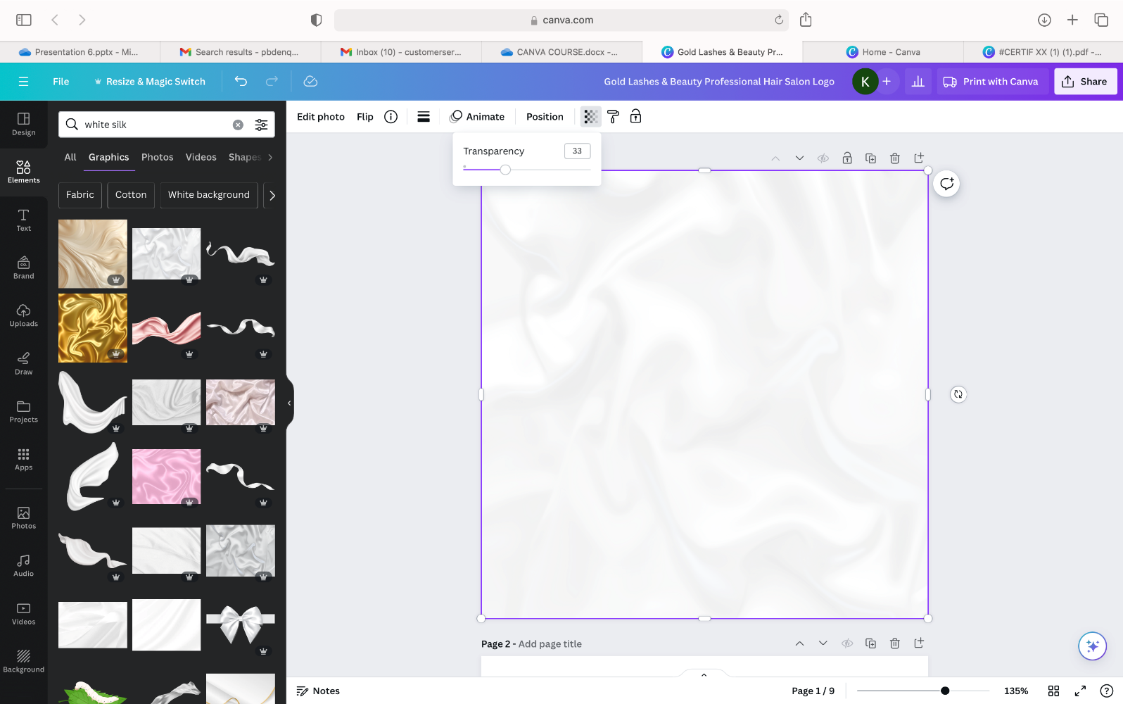
As you can see here, we have changed are transparency to 38 to soften the background but keep the texture there.
The next thing we are going to do is add text onto the post so that it is clear what the post is about by just looking at your Instagram feed.
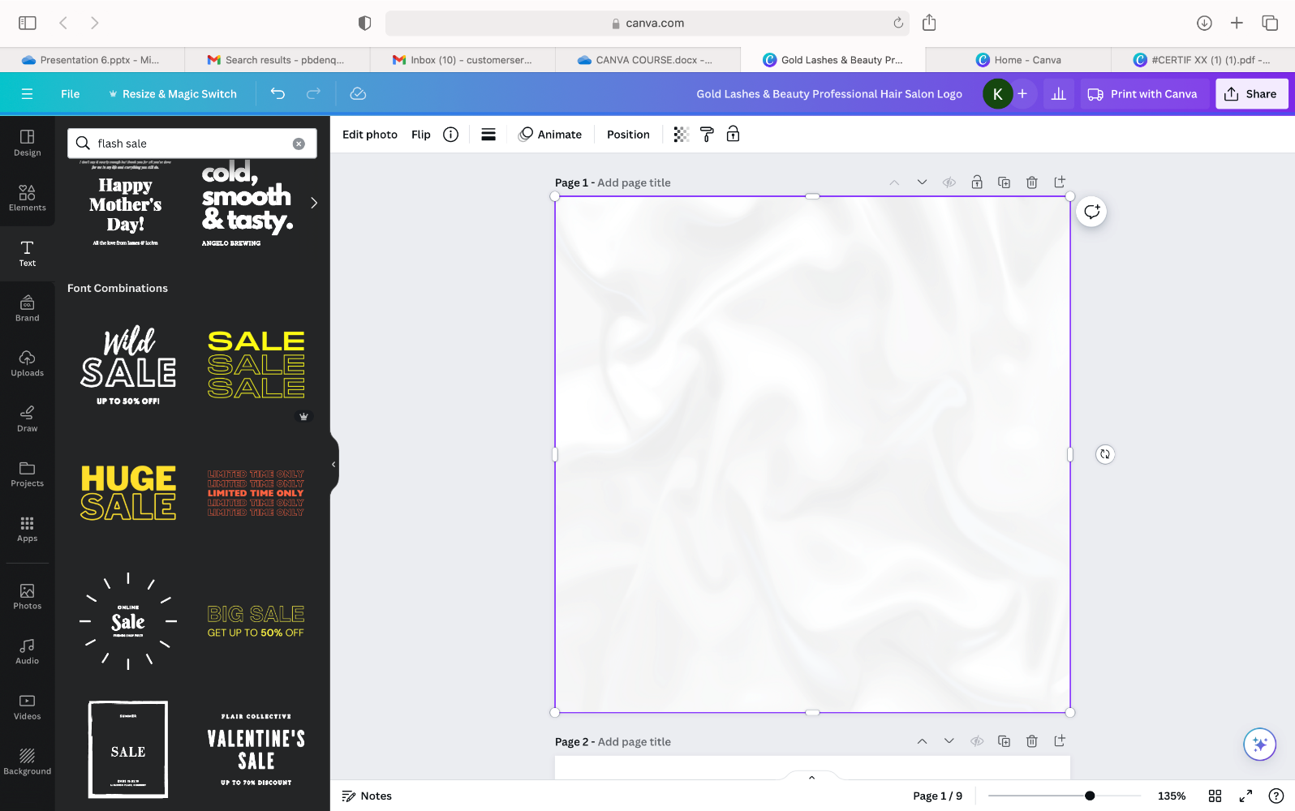
This can be done by either using one of the suggest fonts in the ‘text section’ and typing in what you would want to type.
Or you can add a text box by clicking the heading on the text section.

Once you have added a text box then choose which font you would like to use. This font needs to be bold enough to see from a phone screen but also eye catching and interesting.
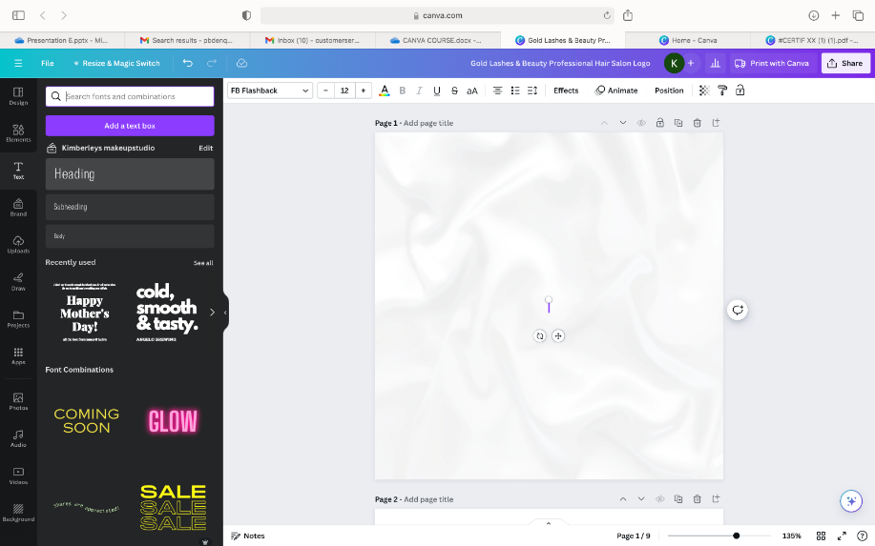
We recommend these fonts.
-league spartan
- Archivo black
-Brittaney
- benedict

For the title of this post, we have changed the fonts on both words to make it more appealing.
We have used “Brittaney” for the word sale, and “league spartan” for the word flash.
We have also changed the placement of the words this is all personal preference, whether that’s in the middle of the post right, at the top or slightly off centre. We have decided to use the slightly off centred format.
Once you have chosen your heading and your fonts, the next thing we will need to do is change how the font looks on the background. This is again to just keep that extra appeal to the Instagram post and make sure that it is going to stand out when posted on to the Instagram feed.
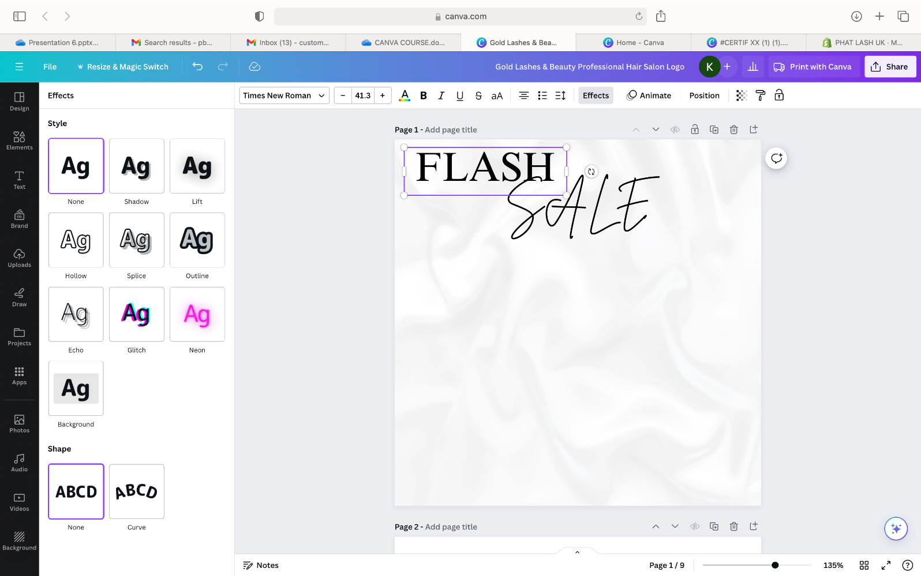
If you click on the text box that you would like to edit, then go onto the ‘effects section’ at the top right-hand side of the page, you can change how the writing looks against the page.
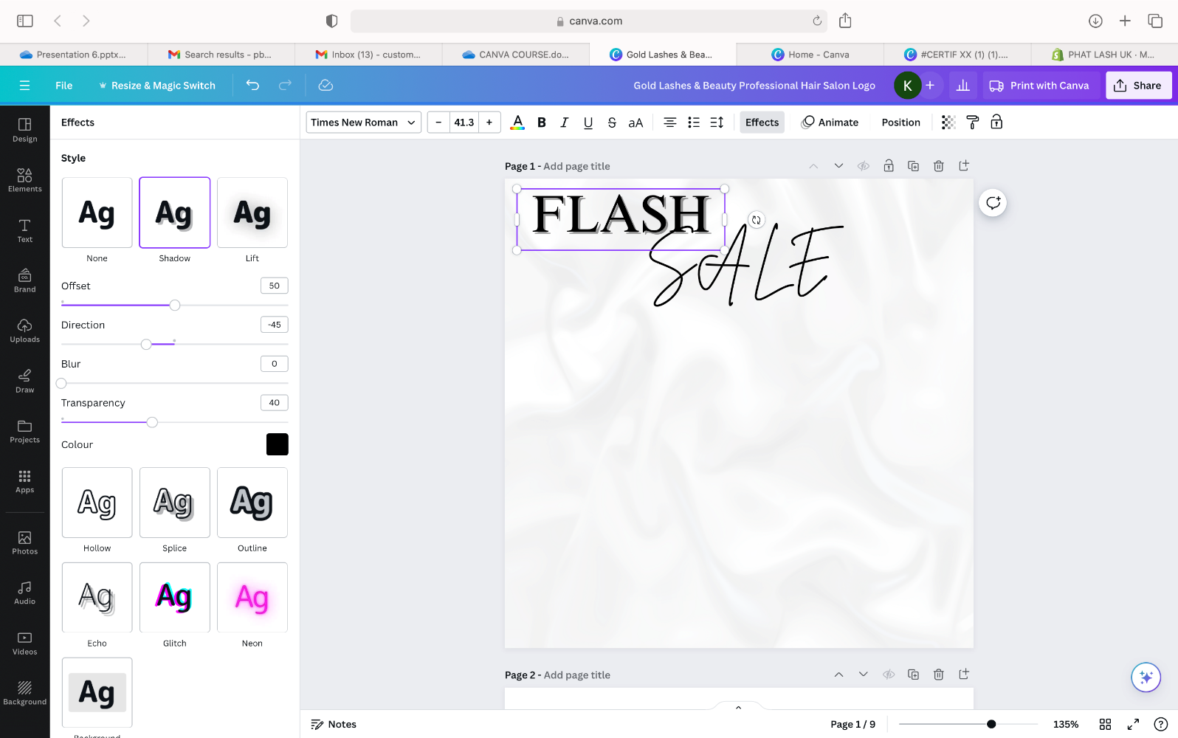

You can add a shadow by clicking the shadow box underneath styles.
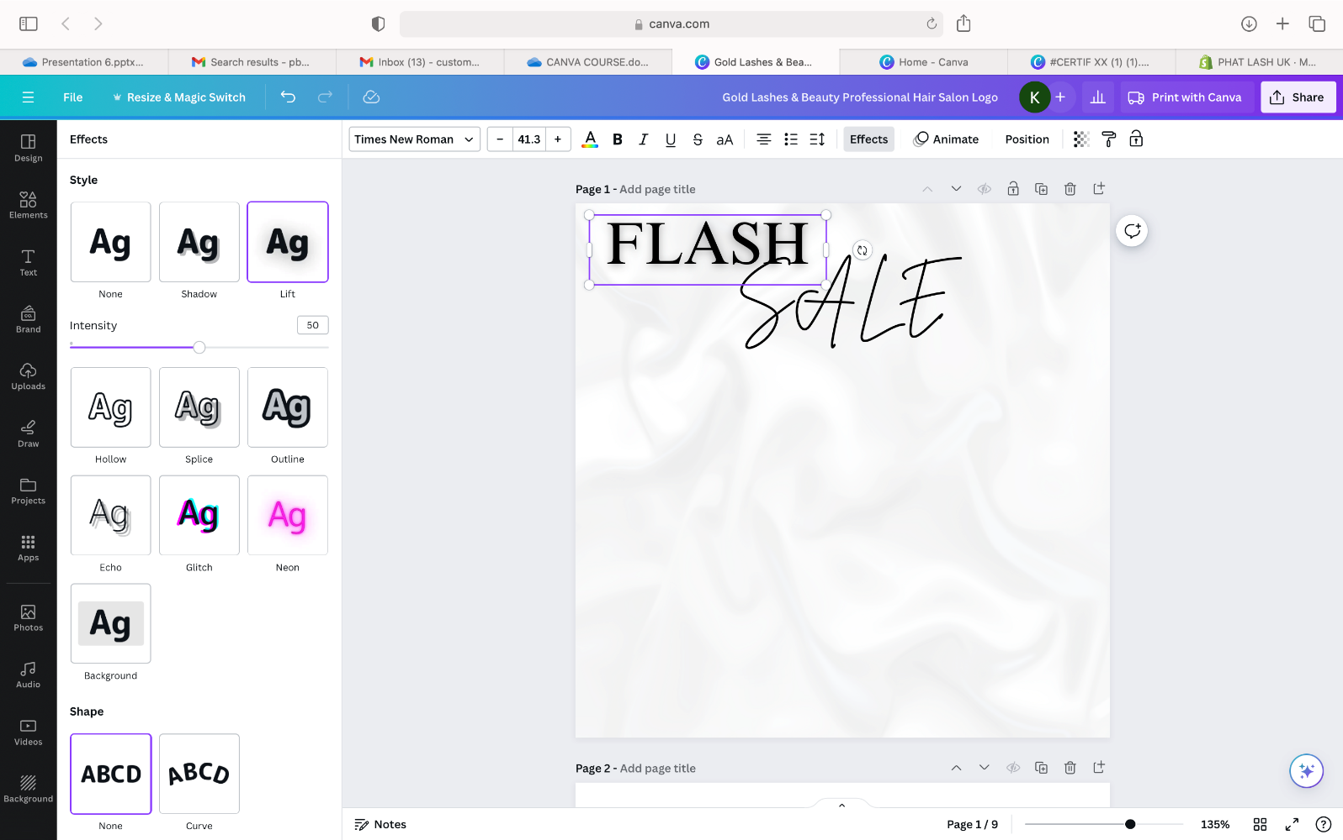
This can also be adjusted, for example, the direction of the shadow, how harsh you would want it to be, using offset to create a bigger gap from the letters to the shadow of the letters.

One that we tend to use is the lift effect. We will follow the same instructions of clicking the text going to effects then selecting the lift style instead of shadow.
We will follow this same process with the word sale.
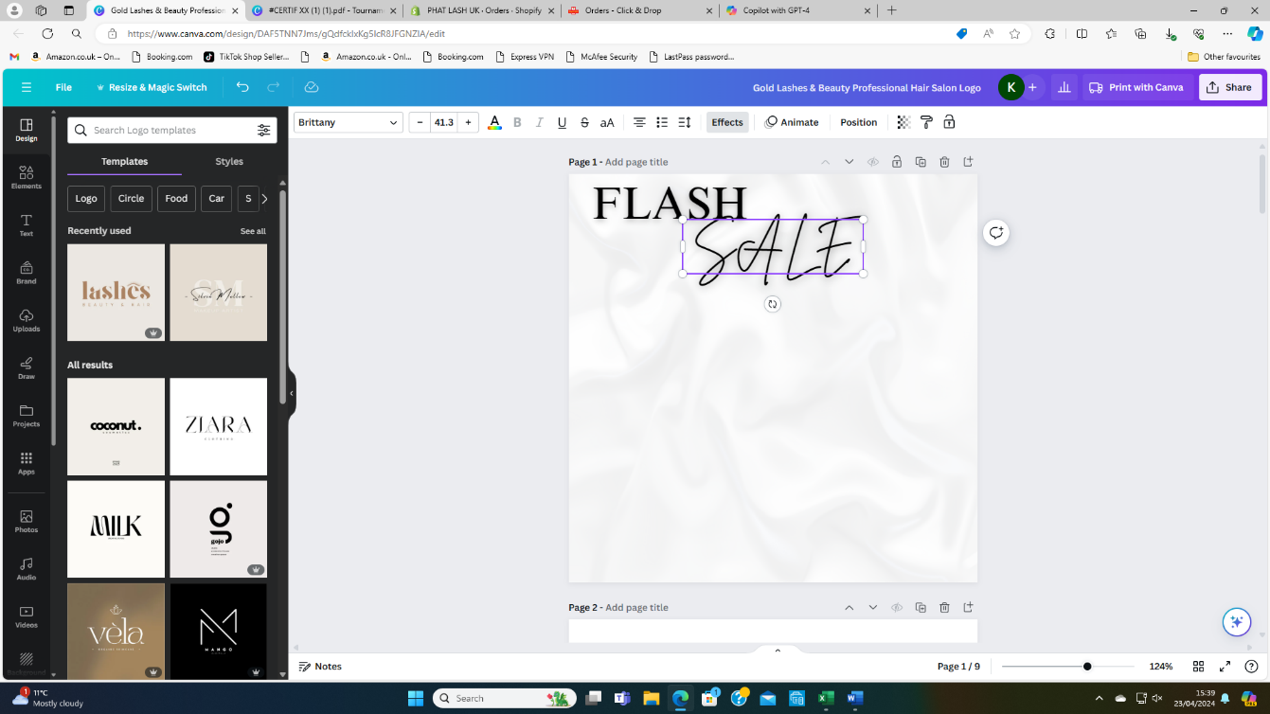
After this you can the add in whatever you want by using the same process of adding text or even adding picture like was demonstrated earlier.
Too make sure that all of your canvas have the same consistant theme and match your instagram and logos colours

For example
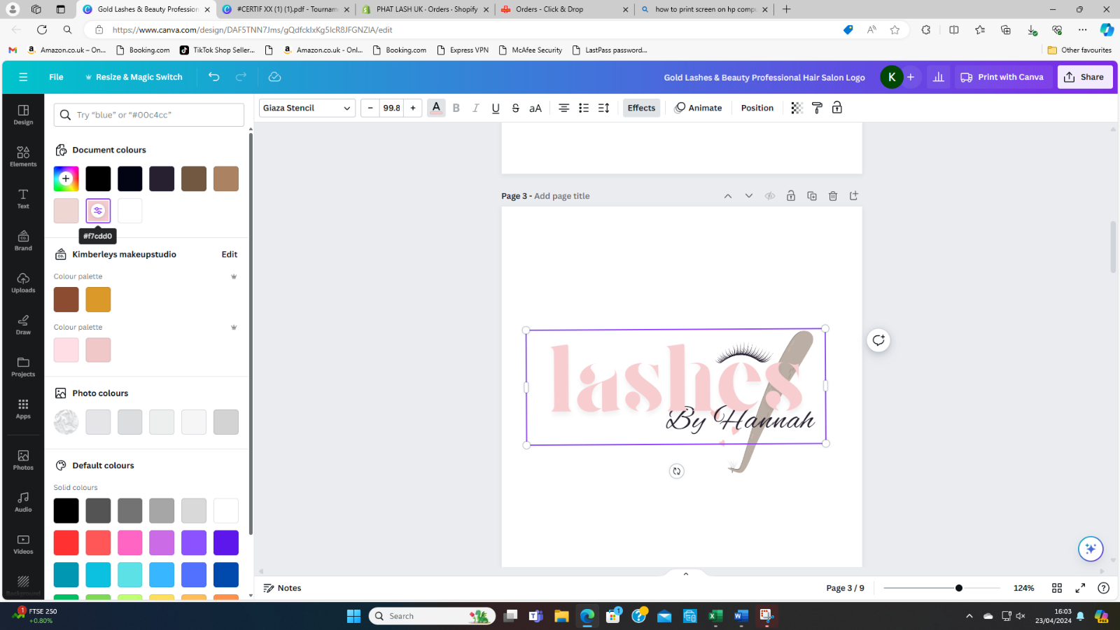
If we use the logo we made before we can see what colour pink we used to create this.

by clicking on the logo after you have changed the colour of your text you can go onto the ‘coloured fonts tab’ and see exactly what colour pink or any colour you have chosen to use.
In this instance we have used a light pink. To get this exact pink easily available t6o use if we want to either use it as a background or a font colour once again, we can save so it is accessible.

We will be adding this to the colour palette that we already have.

Whilst still having the font colour selected next to the colour palette section, we are going to click ‘edit’.
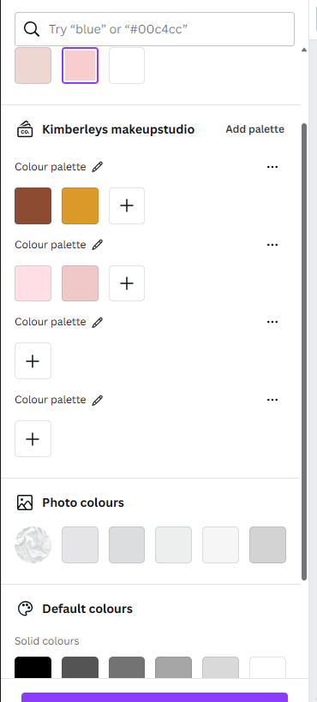
This should appear once you have clicked the
Edit section. If you have would like multiple
Different palettes you can add different ones.
However, we won’t need to add a new one
For this.
Make sure to keep the
colour selected throughout.

Then you clan click the + button to add your colour to the palette

Canva also offers an Instagram story template. When creating Instagram story’s, it can be different to creating posts as you are limited with space, this means that you won’t be able to add the same amount of information to a story as you would an Instagram post.
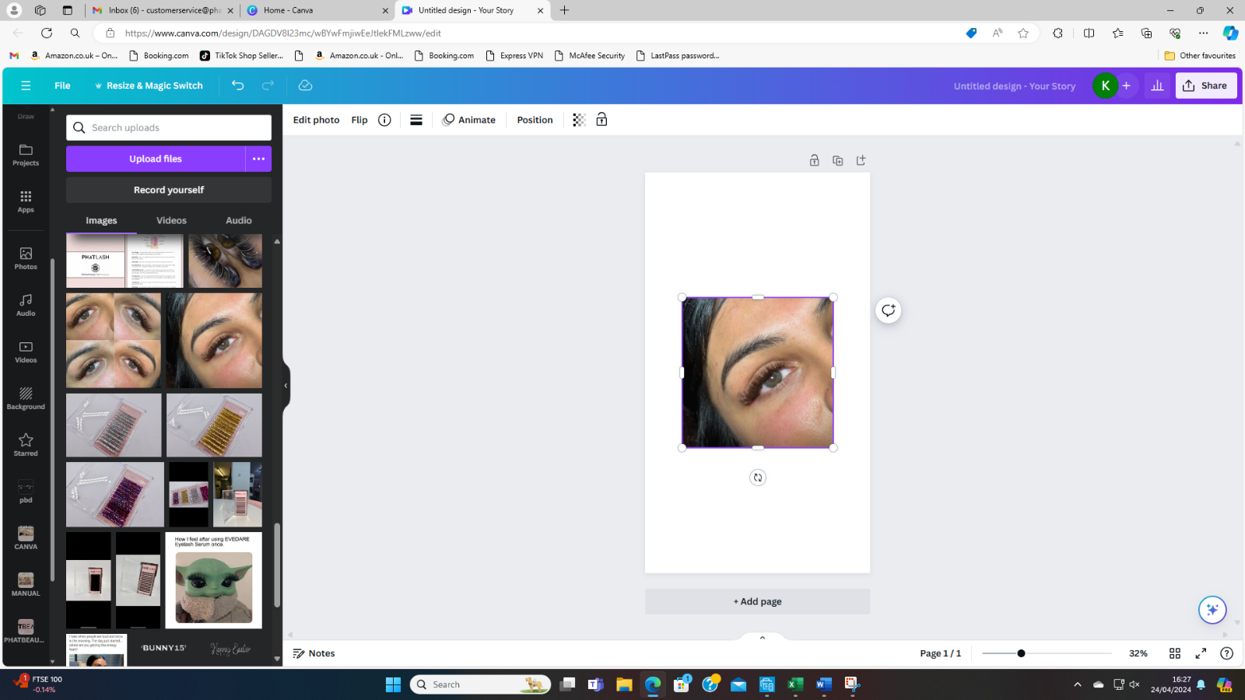
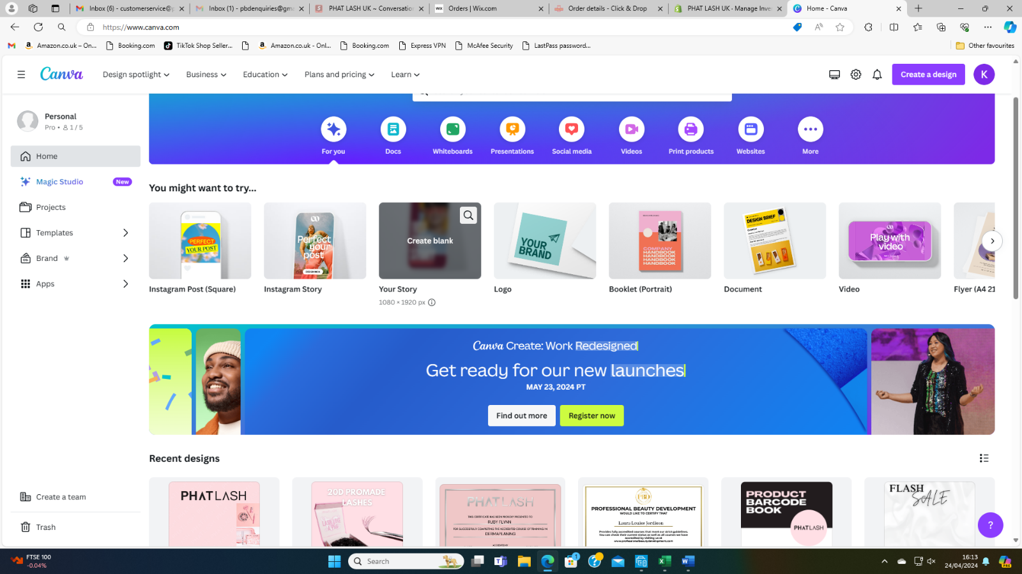
For Instagram story’s you will need to make them more appealing and make me people stop to look or swipe up to ask questions or go over to your Instagram page. Instead of going to the Instagram post template this time we are going to choose ‘Instagram story’. Once this template is chosen, we are going to do the same technique as the Instagram post background.

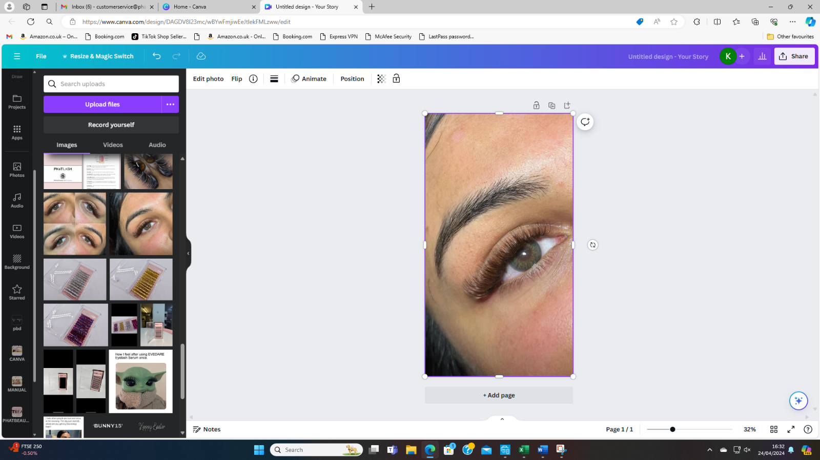
For this we have gone through the same process as we have mentioned before and uploaded a picture from our personal file of a set of lashes this can either be one using your products or a picture of a set that you yourself has done.

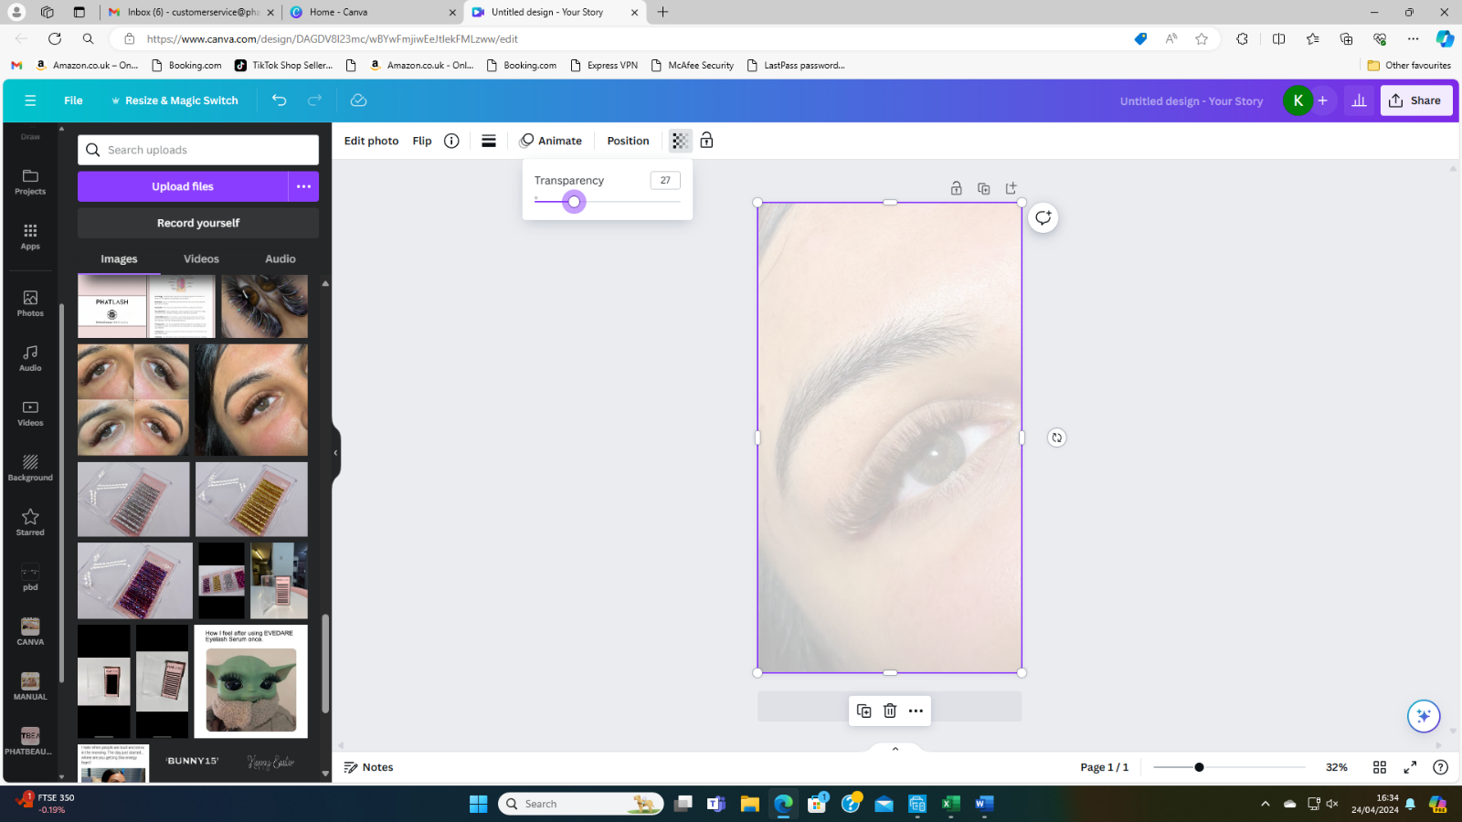
We have then changed the dimensions of the picture that it will fit the entire blank space of the story.

The changing the opacity of the background picture to allow other aspects of the story to stand out and keeping this as your background.
Next you are able to add any text you would like over this such as price lists or availabilty that you have or anything new you are bringing out. As I saids before, storys will not have the same amount of information as a instagram post however will still need to look appealing and match with your instagram feed.
For this one we are going to be demonstrating a price list to show how we would suggest doing it. This can be changed to match the theme of your instagram using colours that you have saved in your colour pallet.

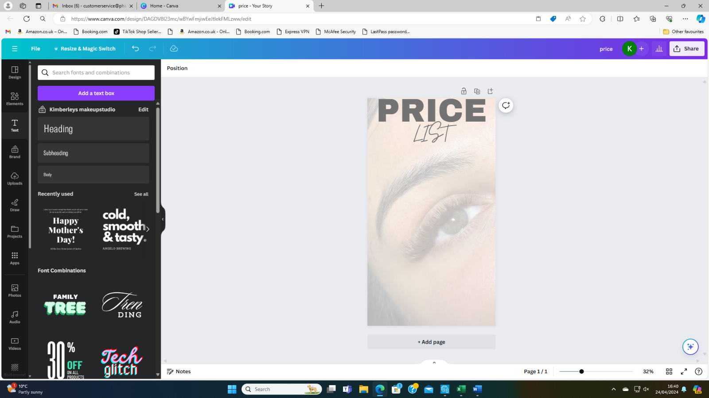
The first thing we are going to do is add our text, I have used league spartan for the word ‘price’ and brittaney for the word ‘list’
Im then going to change the letter spacing this is to make sure that everything is cohesisve with the story.
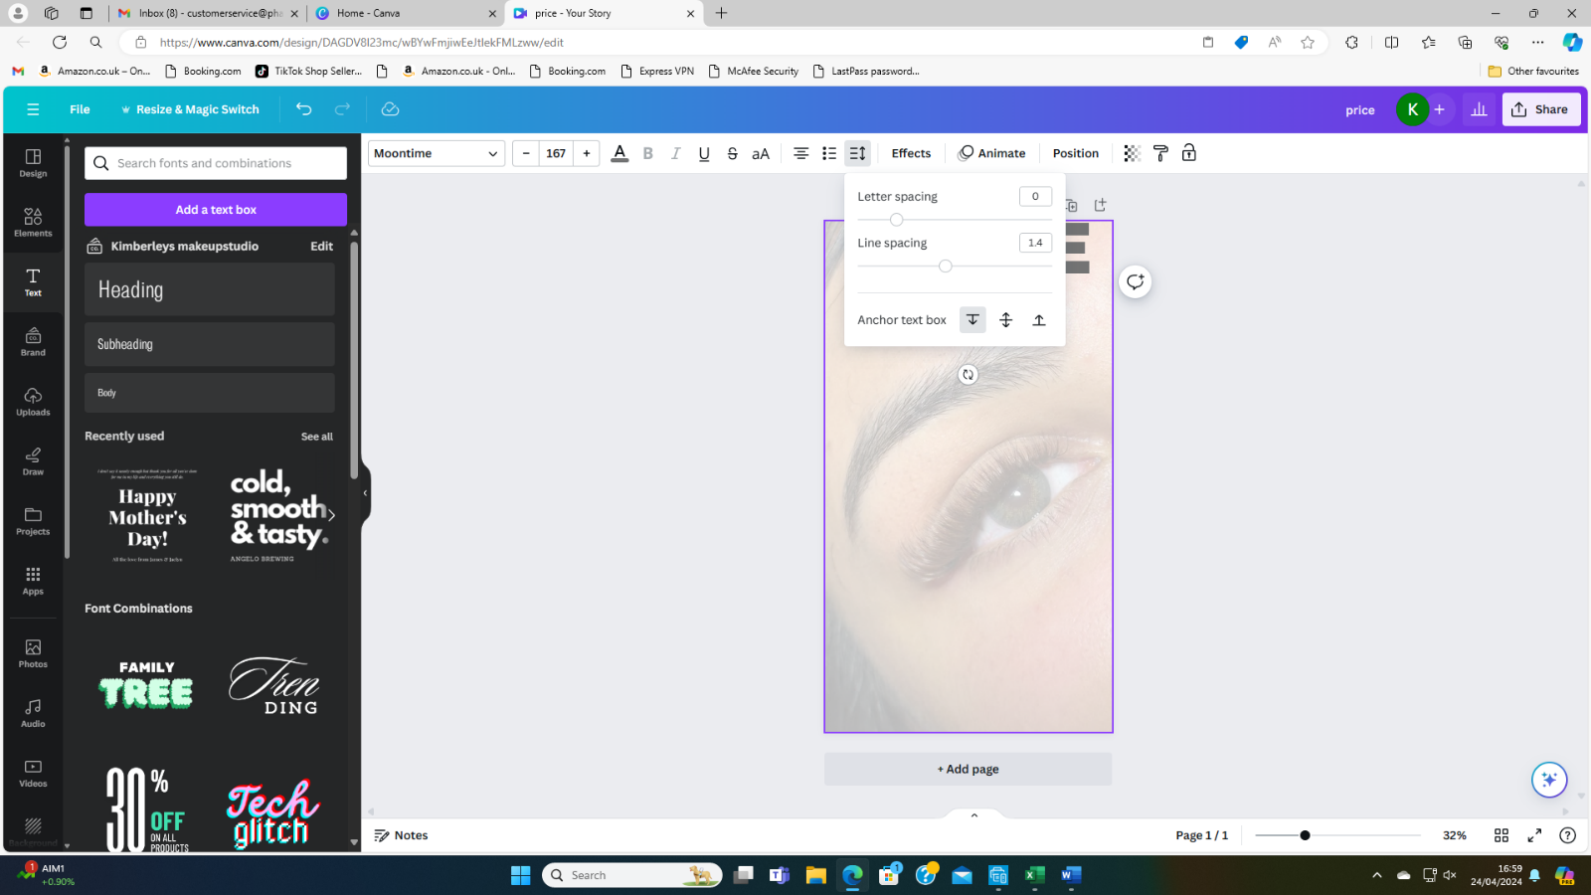
By clicking this button at the top you are able to change the spacing of your letters.
We recommend doing this when you have a smaller word underneath a longer word, seen here, as it keeps the writing at the top of the post more level and matching. 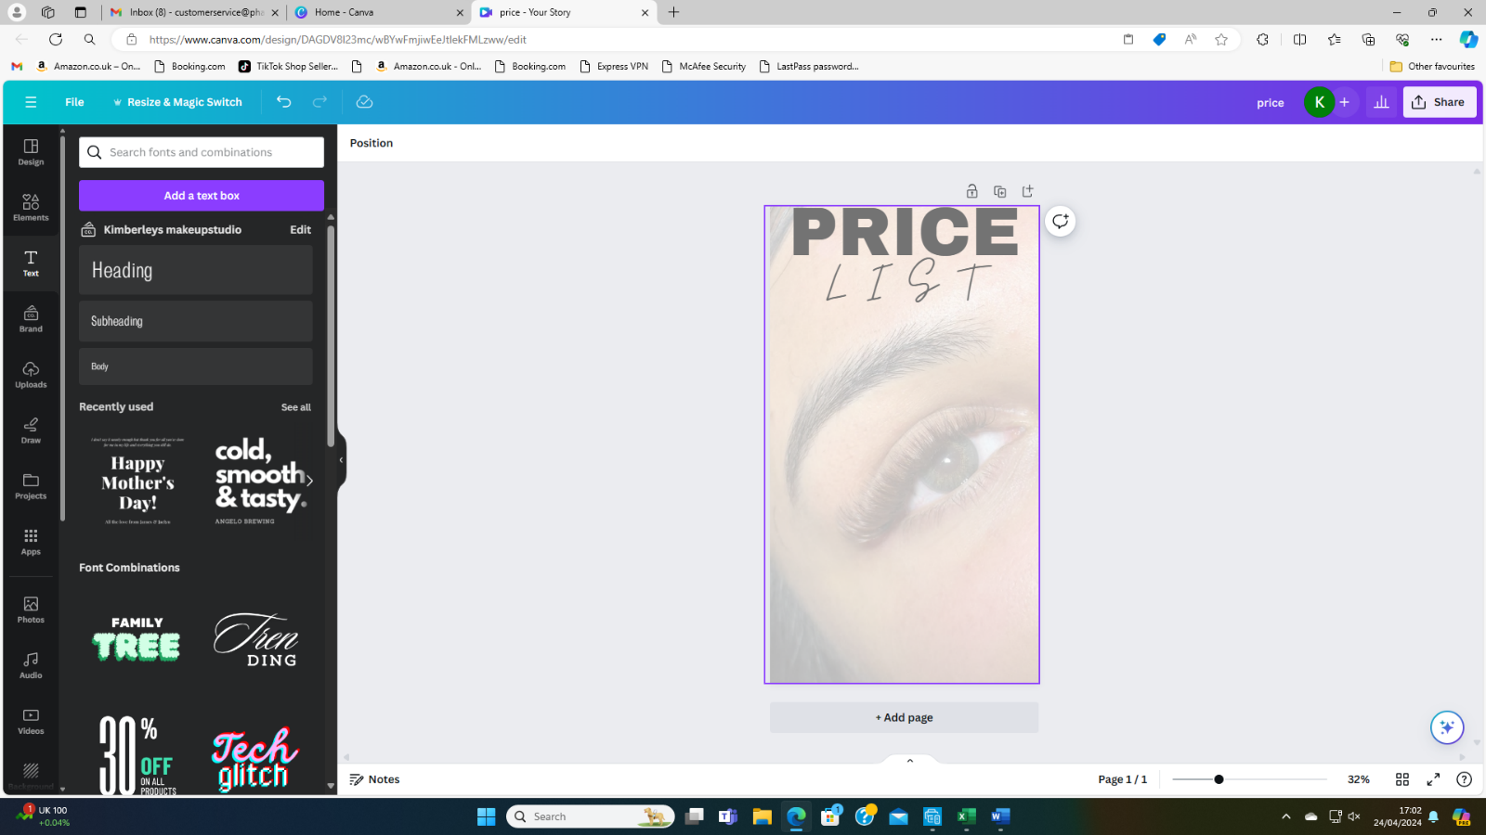
Once we have changed the letter spacing we are now going to go into elements to add whatever we feel seems fit.
For example, we are going to add grey hearts as bullet points to the side of the screen to show what are prices are.
To do this we are going to search in the ‘elements’ sections.
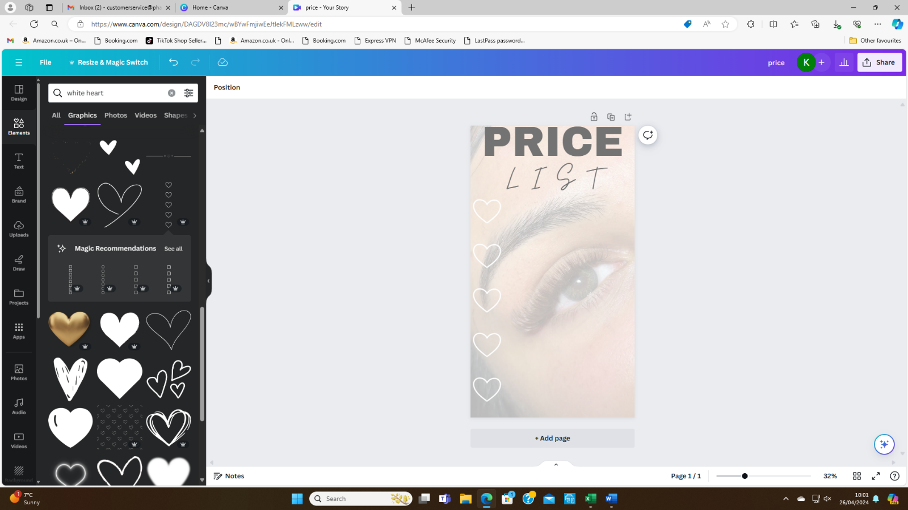

Once you have added what you want to the side of your picture you can then add the text.
This text should match one of the fonts that you have already used. Again this keeps the overall image coheesive and matching. We would recommend using the same fonts for most of your posts to again keep this same theme. When you are running a instagram account. To keep the instagram page looking profession you can also add highlight covers to the front of your storys this will make sure people can easily find what they want to look at through highlights.
This can be done to whatever style you want, wether that is just using your logo to the cover of your highlight or you can add a image that will give a insight to what is in the highlight.

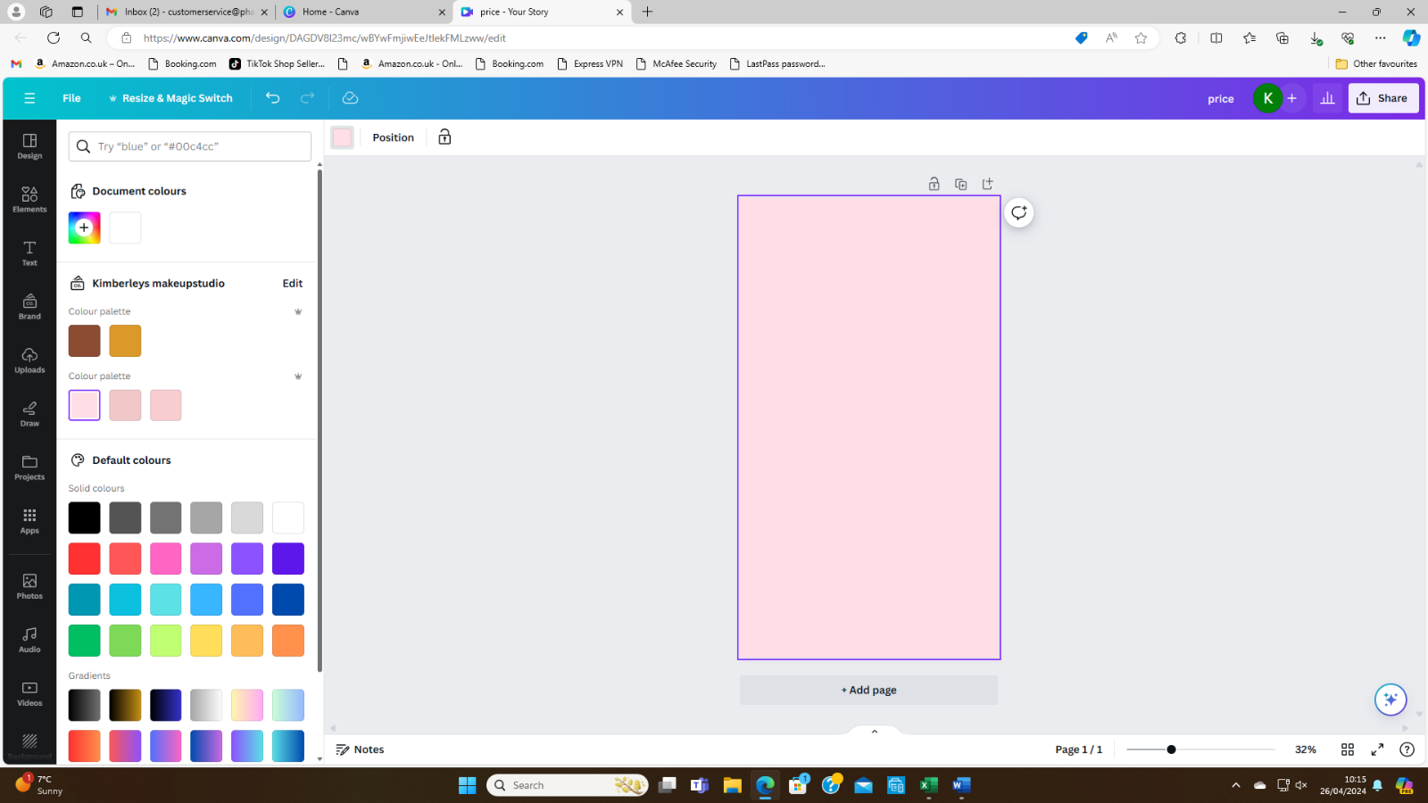

The first thing we have done is add one of our saved background colours to the page, we did this by clicking onto the page then selecting the ‘rainbow square’ at the top left-hand side of the screen.
Once we have done this, we will need something that will signify what in the highlight.
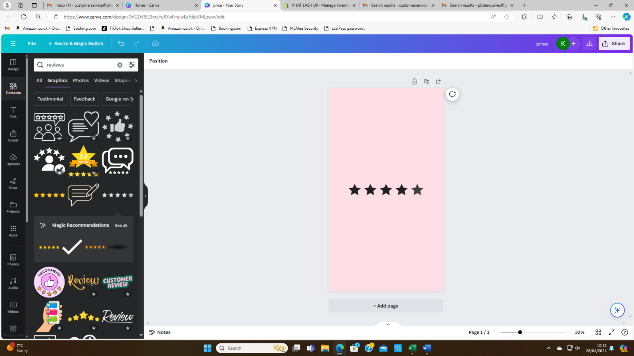

We have gone to the ‘elements’ area and typed in reviews and added what we think will look best. This can either be left like this or we can add more to image.
As this is for a highlight, we are going to use something that will fit in the little circle.
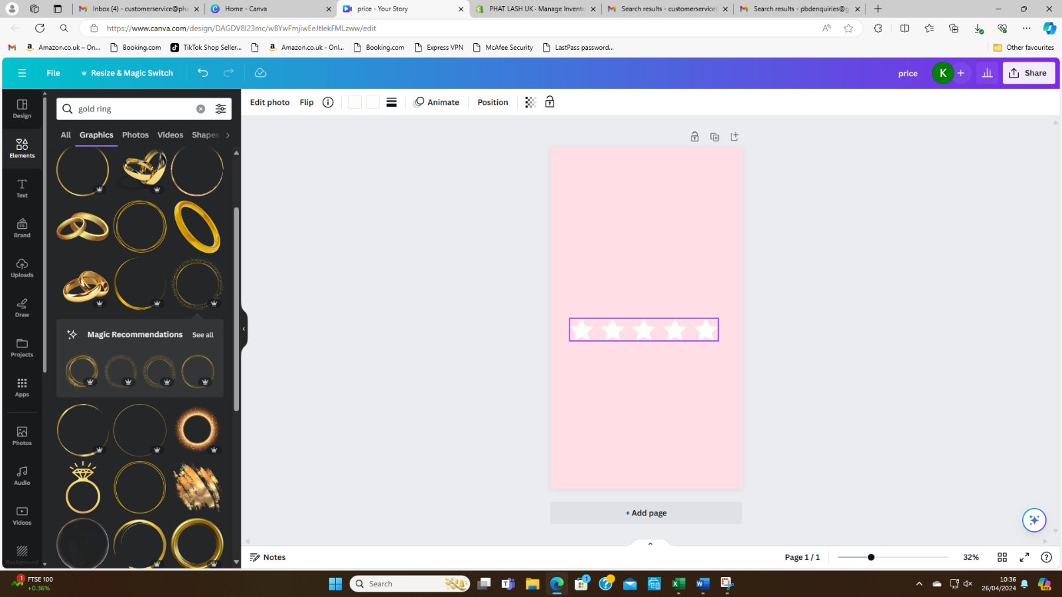
We have changed the colour of the images to white to match the theme.
We have done this by selecting the image and going to the that have the colour of the image in them. Once you have gone to this ‘top boxes’ you can then change the colour of the image.
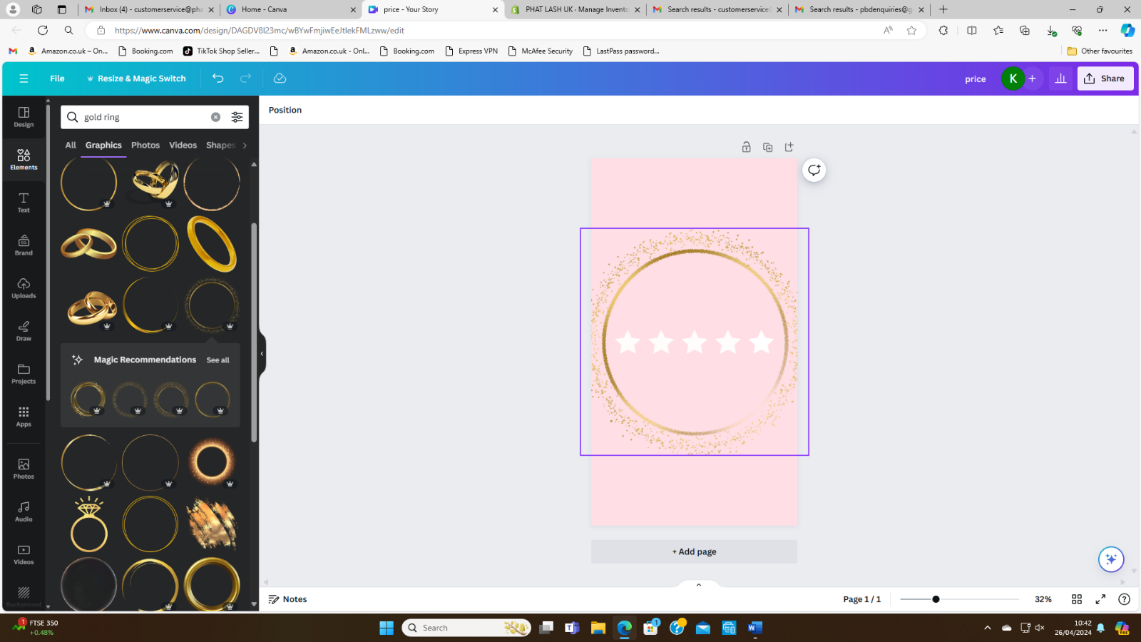

We have once again gone to the ‘elements’ section and added a gold ring that will fit around the highlight to give the highlight more effect.
This can be changed to whatever image that will match what the highlight is about. For example, adding a pound sign to your highlight about prices or adding a set of lashes to your clients’ pictures highlight.

Adding pictures into elements
You can also add pictures into some elements when you are making Instagram posts.
For example.
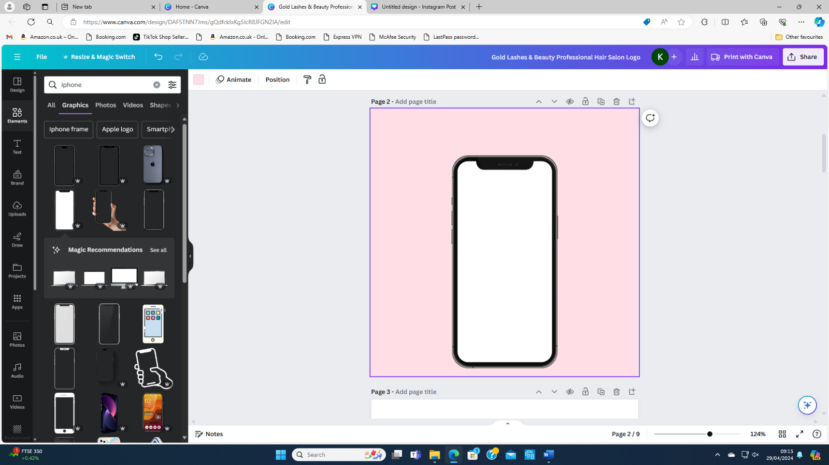We have made a pink post and then added an iPhone outline through the elements section.
This is done by searching iPhone on the elements section and picking whichever one you like best.

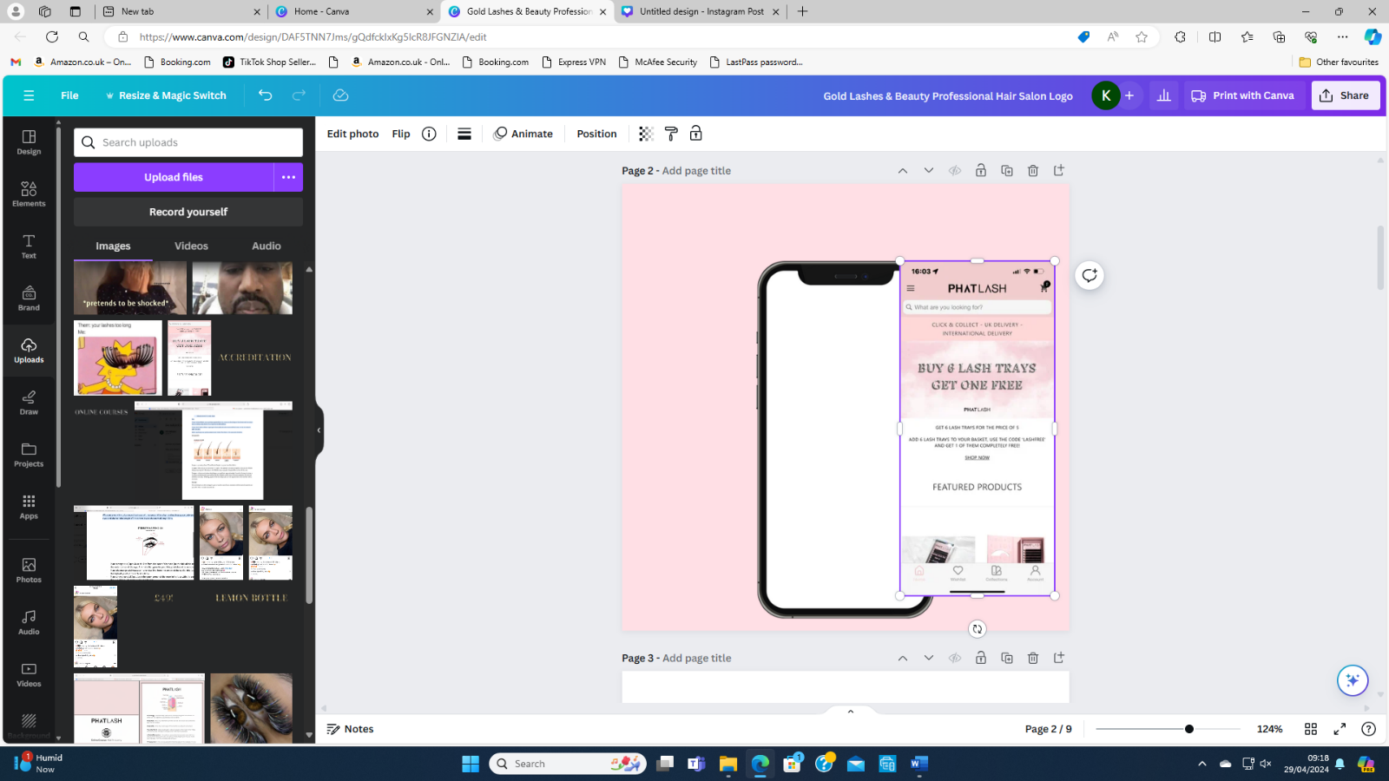

Once we have added a photo of a phone, we are then going to add a picture in the middle for this we have used a ‘screenshot’ of our website that we have then downloaded and then uploaded through the upload section on Canva. This then will need to be moved so it will fit the size of the phone.
This will be done by changing the width and high of the image using the ‘white tabs’ on all the sides.
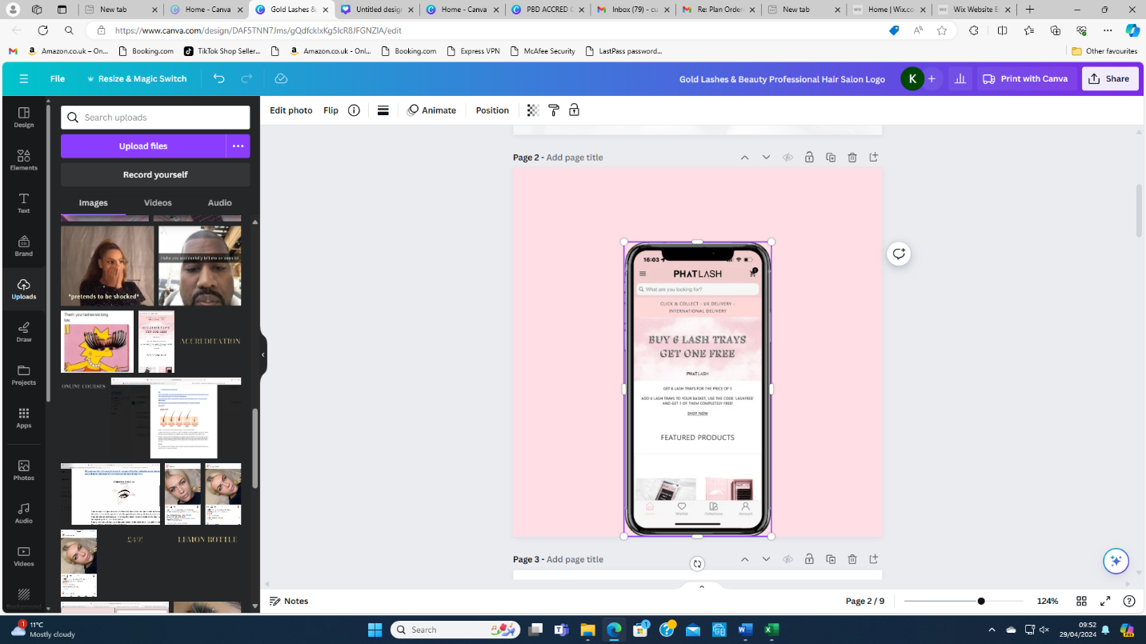

Then you can send the photo to the back by selecting ‘layer’ when you left click the image. After this you will need to add text and could add arrows to show where to go, what ever you think would look best.

